Passwordless Cloud Authentication using Biometric - Derived Keys and Signature of Elliptic Curve
A project report submitted in partial fulfilment of the requirement for the award of the degree of
BACHELOR OF TECHNOLOGY
in
COMPUTER SCIENCE AND ENGINEERING
Submitted by
PENKI JYOTHI (5221411202)
KOSURU KAMAKSHI (5221411192)
YARRA VASU (5221411169)
Y V AVINASH (5221411210)

Under the Esteemed Guidance of
Dr. Bh. PADMA, M. Tech, PhD
Professor

DEPARTMENT OF COMPUTER SCIENCE AND ENGINEERING
ENGINEERING AND TECHNOLOGY PROGRAM
GAYATRI VIDYA PARISHAD COLLEGE FOR DEGREE AND PG COURSES (A)
Rushikonda, Visakhapatnam - 45
(Approved by AICTE| Accredited by NBA| Accredited by NAAC| Affiliated to Andhra University)
An ISO 9001:2015 Certified Institution
2022-2026
DEPARTMENT OF COMPUTER SCIENCE AND ENGINEERING
GAYATRI VIDYA PARISHAD COLLEGE FOR DEGREE AND PG COURSES (A)
Rushikonda, Visakhapatnam - 45

CERTIFICATE
This is to certify that the project report entitled “Passwordless Cloud Authentication using Biometric-Derived Keys and Signature of Elliptic Curve” being submitted by PENKI JYOTHI (5221411202), KOSURU KAMAKSHI (5221411192), YARRA VASU (5221411169), Y V AVINASH (5221411210) in the partial fulfilment for the award of the Degree of Bachelor of Technology in Computer Science and Engineering to the Gayatri Vidya Parishad College for Degree and PG Courses (A), Visakhapatnam is a record of Bonafide work carried out under my guidance and supervision.

Project Guide | Head of the Department
Dr. Bh. Padma | Dr. G.R.S Murthy
Professor | Professor
MTech, PhD | M. Tech, Ph. D

External Examiner

VISION AND MISSION OF THE INSTITUTE

VISION

Creating Human Excellence for a Better Society

MISSION

Unfold into a World class organization with strong academic and research base, producing responsible citizens to cater to the changing needs of the society.

VISION AND MISSION OF THE DEPARTMENT

VISION

“Create and sustain as a Centre of excellence in Computer Science and Engineering and allied areas of research to pave the way for providing better technocrats to the society.”

MISSION

“To provide strong conceptual base (M1) for acquiring programming skills, to develop high computational innovative skills (M2) and to empower leadership qualities with strong ethical base (M3)”

PROGRAM OUTCOMES (POs)
PO 1: Engineering knowledge: Apply the knowledge of mathematics, science, engineering fundamentals, and an engineering specialization to the solution of complex engineering problems.
PO 2: Problem analysis: Identify, formulate, review research literature, and analyses complex engineering problems reaching substantiated conclusions using first principles of mathematics, natural sciences, and engineering sciences.
PO 3: Design/development of solutions: Design solutions for complex engineering problems and design system components or processes that meet the specified needs with appropriate consideration for the public health and safety, and the cultural, societal, and environmental considerations.
PO 4: Conduct investigations of complex problems: Use research-based knowledge and research methods including design of experiments, analysis and interpretation of data, and synthesis of the information to provide valid conclusions.
PO 5: Modern tool usage: Create, select, and apply appropriate techniques, resources, and modern engineering and IT tools including prediction and modelling to complex engineering activities with an understanding of the limitations.
PO 6: The engineer and society: Apply reasoning informed by the contextual knowledge to assess societal, health, safety, legal and cultural issues and the consequent responsibilities relevant to the professional engineering practice.
PO 7: Environment and sustainability: Understand the impact of the professional engineering solutions in societal and environmental contexts, and demonstrate the knowledge of, and need for sustainable development.
PO 8: Ethics: Apply ethical principles and commit to professional ethics and responsibilities and norms of the engineering practice.
PO 9: Individual and team work: Function effectively as an individual, and as a member or leader in diverse teams, and in multidisciplinary settings.
PO 10: Communication: Communicate effectively on complex engineering activities with the engineering community and with society at large, such as, being able to comprehend and write effective reports and design documentation, make effective presentations, and give and receive clear instructions.
PO 11: Project management and finance: Demonstrate knowledge and understanding of the engineering and management principles and apply these to one’s own work, as a member and leader in a team, to manage projects and in multidisciplinary environments.
PO 12: Life-long learning: Recognize the need for, and have the preparation and ability to engage in independent and life-long learning in the broadest context of technological change.

PROGRAM EDUCATIONAL OBJECTIVES (PEOs)
PEO1: Ability to develop hardware and software problem solving capabilities by inculcating strong fundamental, analytical, and communication skills.

PEO2: Ability to build confidence to address the challenges in their work and to apply innovative technical tools through interaction with professional bodies.

PEO3: Ability to gain sufficient depth of knowledge, Self-learning skills, technical skills and leadership qualities through participating in personality development activities, so as to sustain in multidisciplinary environment.

PEO4: To be able to respond to societal needs in professional and ethical concerns.

PROGRAM SPECIFIC OUTCOMES (PSOs)
PSO 1: System Inception and Elaboration: Conceptualize the software and/or hardware systems, system components and processes/procedures through requirement analysis, Modelling/Design of the system using various architectural/design patterns, Standard Notations, procedures and algorithms.

PSO 2: System Construction: Implement the systems, Procedures and Processes using the state-of-the-art technologies, standards, tools and Programming Paradigms.

PSO 3: System Testing and Deployment: Verify and Validate the Systems, Procedures and Processes using various testing and verification techniques and tools.

PSO 4: Quality and Maintenance: Manage the quality through various product development strategies under revision, transition and operation through maintainability, flexibility, testability, portability, reusability, interoperability, correctness, reliability, efficiency, integrity and usability to adapt the system to the changing structure and behaviour of the systems/environments.

DECLARATION
We hereby declare that the project entitled “Password less Cloud Authentication using Biometric-Derived Keys and Signature of Elliptic Curve” submitted in partial fulfilment of the requirements for the award of Bachelor of Technology in Computer Science and Engineering, to Engineering and Technology Program, Gayatri Vidya Parishad College for Degree & PG Courses (A). We assure that this project is not submitted in any other University or College.

Name & Signature of the Students

PENKI JYOTHI (5221411202)

KOSURU KAMAKSHI (5221411192)

YARRA VASU (5221411169)

Y V AVINASH (5221411210)

ACKNOWLEDGEMENTS
With great pleasure we want to take this opportunity to express our heartfelt gratitude to all the people who helped in making our main project work a grand success.
Firstly, we express our deep sense of gratitude to Sri. Bh. Padam, Professor, for her constant guidance throughout our main project work.
We are grateful to G. Kalyan Chakravarthi, Assistant Professor, for his valuable suggestions and guidance given by him during the execution of this main project.
We would like to thank Dr. G.R.S Murthy, Professor, Head of the Department of Computer Science and Engineering, for being moral support throughout the period of our study.
We are highly indebted to Dr. P.V. Vinay, Director and Prof. K S Bose, Principal for giving us the permission to carry out this main project in the college.
We would like to thank all the Teaching and Non-Teaching staff of CSE Department for sharing their knowledge with us.

PENKI JYOTHI (5221411202)
KOSURU KAMAKSHI (5221411192)
YARRA VASU (5221411169)
Y V AVINASH (5221411210)

ABSTRACT
Cloud authentication traditionally relies on password-based mechanisms, which suffer from vulnerabilities such as credential theft, phishing, and weak password practices. To address these challenges, this project proposes a biometric-driven authentication mechanism based on Elliptic Curve Cryptography (ECC). A fixed-length hash is derived from biometric input, which in turn is transformed into a scalar suitable for ECC operations. This paper proposes a Passwordless authentication scheme leveraging biometric data combined with elliptic curve cryptography (ECC). The biometric sample is processed through a secure hash function to derive a secret scalar, which is then used to generate ECC private and public keys. Authentication is performed via ECDSA signatures without transmitting the biometric data itself, ensuring privacy and strong security guarantees. This method eliminates password-related risks, enhances user experience, and resists phishing, replay, and credential stuffing attacks.

TABLE OF CONTENTS
CHAPTER | Page No
1. Introduction  1.1 Introduction to ECC  1.2 Applications  1.3 Introduction to Biometric Features  1.4 ECC Keys |  | 1  1  3  4  6
2. Literature Survey |  | 8
3. Requirements and Analysis  3.1 Existing System  3.2 Proposed System  3.3 Functional Requirements  3.4 Non-Functional Requirements  3.5 Security & Threat Analysis |  | 13  13  14  16  19  22
4. System Design  4.1 Design Goals  4.2 System Architecture  4.3 System Design  4.4 UML Diagrams |  | 24  25  26  27  29
5. Implementation  5.1 System work flow  5.2 Biometric Features Extraction Module  5.3 Implementation Tools and Technologies  5.4 Database Design |  | 41  41  41  43  44
6. Testing  6.1 Testing Activities  6.2 Testing Types  6.3 Test Cases |  | 45  45  45  46
7. Results  7.1 Index Page  7.2 Register Page  7.3 Login Page  7.3.1 Login Page Fingerprint Verification  7.3.2 Login Page key match verification  7.3.3 Private Key Verification  7.3.4 Login Page ECDSA Signature Authorization  7.4 Dashboard of User  7.5 System Admin Page  7.6 Flask Server |  |  | 49  49  49  50  50  51  51  52  52  53  53
8. Sample Code  8.1 Code for Index.html  8.2 Code for Register.html  8.3 Code for login.html  8.4 Code for app.py |  |  | 54  54  56  58  60
9. Conclusion |  |  | 64
10. References |  |  | 65

LIST OF TABLES
TITLE | Page No
6.3 Test Cases  6.3.1 Identity& Public Key Verification  6.3.2 Biometric Capture & Key Reconstruction  6.3.3 ECDSA Signature & Authorization | 46  46  47  48

LIST OF FIGURES
TITTLE | Page No
3.4.1.1 Mantra RD MFS110  4.2.1 System Architecture  4.4.1 Use Case Diagram  4.4.2 Class Diagram |  | 20  26  31  34
4.4.3 Registration phase of Activity Diagram |  | 36
4.4.3.1 Authentication phase of Activity Diagram |  | 37
4.4.4 Registration phase of Sequences Diagram |  | 39
4.4.4.1 Authentication phase of Sequences Diagram  7.1 Index Page  7.2 Register Page  7.3 Login Page  7.3.1 Login Page Fingerprint Verification  7.3.2 Login Page key match verification  7.3.3 Private Key Verification  7.3.4 Login Page ECDSA Signature Authorization  7.4 Dashboard of User  7.5 System Admin Page  7.6 Flask Server |  | 40  49  49  50  50  51  51  52  52  53  53

1.INTRODUCTION
Passwordless cloud authentication using biometric-derived keys (often leveraging Elliptic Curve Cryptography, or ECC) is a modern, high-security approach that eliminates traditional passwords, shared secrets, and the risk of server-side credential theft.
It works by allowing a user to unlock a locally stored, hardware-bound private key using a biological trait (fingerprint, facial recognition), which then signs a authentication challenge. This method is phishing-resistant, cryptographically secure, and aligned with FIDO2/Webathon standards.
Biometric Authentication
Biometric authentication stands at the forefront of passwordless technologies, utilizing unique physical or behavioural characteristics to verify a user's identity. This method capitalizes on the inherent traits of individuals, offering a high level of security and convenience.
Facial Recognition: Analysis facial features to create a digital representation that is matched against a stored template.
Fingerprint Scanners: Uses the unique patterns of an individual's fingerprints as a secure access key.

1.1 Introduction to Elliptic Curve Cryptography (ECC)
Neal Koblitz and Victor S. Miller independently proposed the use of elliptic curves in encryption in 1985.Elliptic curve cryptography algorithms entered wide use from 2004 to 2005. In the mid-1980s, researchers found that examining elliptic curves could lead to the discovery of new sources of difficult problems. Elliptic Curve Cryptography (ECC) introduced a new degree of security to public key cryptosystems, that provide combined encryption and digital signature services. The security of elliptic curve cryptosystems, like that of all public-key cryptosystems, is based on tough mathematical issues at the core. Given two elliptic curve points G and Y, were Y = k G
- Symmetric-key Encryption (secret key encryption): Symmetric-key algorithms are cryptographic algorithms that employ the same cryptographic keys both for plaintext encryption and ciphertext decoding. The keys could be identical, or there could be a simple transition between them.
- Asymmetric-key encryption (public key encryption): Asymmetric-key algorithms encrypt and decrypt a message using a pair of related keys (one public key and one private key) and safeguard it from unauthorized access or usage.
Elliptic Curve Cryptography (ECC) is a modern public-key cryptographic technique used to provide secure communication and authentication in cloud-based systems. ECC operates on the mathematical principles of elliptic curves to generate a pair of keys, namely a private key and a public key. The private key is a confidential value known only to the user, while the public key is derived from it and can be shared openly for verification purposes. Compared to traditional methods such as the RSA algorithm, ECC offers stronger security with smaller key sizes, leading to faster computation and reduced storage requirements. In this project, ECC is used to support passwordless authentication by generating cryptographic keys from biometric data. The biometric-derived key is used to create an ECC private key, which in turn generates a corresponding public key. During authentication, the private key is used to produce a digital signature, and the server verifies this signature using the public key, ensuring secure and efficient user authentication without the need for passwords.
Applications of ECC
Diffie-Hellman: The basic public-key cryptosystem suggested for secret key sharing is the Diffie-Hellman protocol. If A (Alice) and B (Bob) initially agree on a given curve, field size, and mathematical type. They then distribute the secret key in the following manner. We can see that all we need to build the Diffie-Hellman protocol is scalar multiplication.
Elliptic Curve Digital Signature Algorithm (ECDSA): ECC is one of the most widely utilized digital signature implementation approaches in cryptocurrencies. In order to sign transactions, both Bitcoin and Ethereum use the field inverse multiplication, but also arithmetic multiplication, inverse function, and modular operation
1.2 Applications
This system can be used in any application that requires secure, password-less authentication using biometrics and cryptographic techniques.
1.2.1 High-Security Banking & Fintech
In traditional banking, if a hacker steals your password and gets past your SMS code (SIM swapping), they can empty your account.
- Static passwords and SMS codes are intercept able.
- When a user initiates a transfer, the bank's cloud sends a "Challenge." The user scans their finger/face, and their device generates an ECDSA signature linked to that specific transaction.
- Even if a hacker controls the bank's app, they cannot "forge" the signature because they don't have the user's physical biometric to derive the private key. This is called non-repudiation the user cannot claim they didn't make the transfer.
1.2.2. Healthcare
Medical data is 10x more valuable on the black market than credit card data. Hospitals use cloud databases to store patient history.
- Doctors often share passwords or stay logged into terminals, leading to data leaks.
- A doctor must provide a biometric scan to "unlock" the ECC private key required to decrypt or view a patient's file.
- It ensures Privacy Compliance (HIPAA). Every time a record is accessed, a unique digital signature is logged. This creates an unchangeable audit trail of exactly who looked at which patient's data and when.
1.2.3. Smart defence & Government (E-Passports & Voting)
Governments are moving toward "Digital IDs" where your phone is your passport or your voter registration card.
- If a phone is stolen, a digital ID could be used for identity theft.
- The Digital ID is encrypted using a key that can only be derived from the citizens biometric. To vote or cross a border, the person provides a scan, generates an ECDSA signature, and the government cloud verifies it against their registered Public Key.
- It eliminates Identity Fraud. A stolen phone is useless because the "key" to the identity is not stored in the phone's memory—it only exists in the users biometric.

1.2.4. Enterprise "Zero-Trust" Workforce Security
Large companies (like Google or Microsoft) no longer trust passwords for their employees. They use "Zero-Trust" models.
- Employees use weak passwords or fall for phishing emails that steal their credentials.
- To log into the company cloud (Salesforce, AWS, etc.), the employee must use a biometric-derived key.
- A hacker can send a fake login page, but since there is no "password" for the user to type, there is nothing for the hacker to steal. The authentication happens via a cryptographic handshake (ECDSA) that a hacker cannot replicate.

1.3 Introduction to Biometric Features
Biometric features refer to the unique physiological or behavioural characteristics of an individual that can be used for identarian and authentication purposes. These features are inherently linked to a person and are difficult to duplicate or forge.
Common physiological biometric features include fingerprints, iris patterns, facial structure, and palm prints, while behavioural features include voice patterns and typing behaviour. Among these, fingerprint-based authentication is widely used due to its accuracy, reliability, and ease of acquisition.
Biometric systems work by capturing the biometric sample, extracting distinctive features, and comparing them with stored references for authentication. In modern secure systems, biometric features are often combined with cryptographic techniques to enhance security and privacy.
In this project, biometric features are used to generate cryptographic keys, eliminating the need for traditional passwords and providing a secure authentication mechanism.
ECDSA Algorithm (Elliptic Curve Digital Signature Algorithm)
The Elliptic Curve Digital Signature Algorithm (ECDSA) is a cryptographic algorithm used for creating and verifying digital signatures. It provides data authenticity, integrity, and non-repudiation by leveraging the mathematical properties of elliptic curves, offering a high level of security with smaller keys compared to older algorithms like RSA and DSA.
ECDSA is a public-key (asymmetric) cryptosystem, meaning each user has a pair of mathematically linked keys: a secret private key used for signing and a public key used by anyone to verify the signature.
1.3.1 Key Generation
- A private key is a large, randomly generated integer.
- The corresponding public key is a point on the elliptic curve, calculated by performing a specific point multiplication operation: Public Key = Private Key × Generator Point.
- The security lies in the elliptic curve discrete logarithm problem (ECDLP), a "trapdoor function" that makes it computationally infeasible to calculate the private key from the public key.
1.3.2. Signature Generation (Signing a Message)
To sign a message m, the signer performs the following steps:
- A cryptographic hash function (like SHA-256) is used to create a fixed-length message digest z of the message.
- A cryptographically secure random number k is generated for each unique signature. This is critical; reusing k or using a predictable k can compromise the private key.
- Mathematical operations involving k, the private key, the message digest, and the curve parameters produce the two parts of the signature: the integers r and s. The signature is the pair (r, s).
1.3.3. Signature Verification
The recipient (or any third party) can verify the signature (r, s) on message m using only the signer's public key and the curve parameters:
- The recipient calculates the message digest z' from the received message m using the same hash function.
- Mathematical operations are performed on r, s, z', the public key, and the curve's generator point to recover a specific point on the elliptic curve.
- If the x-coordinate of the recovered point matches the r value from the signature, the signature is valid. This confirms the message's authenticity and integrity (it hasn't been tampered with), and that it was signed by the holder of the private key.

1.4 ECC Keys
Public key
Public key cryptography, or asymmetric cryptography is a security system using pairs of keys—a public key for encryption. Elliptic Curve Cryptography (ECC) public keys are points on a predefined elliptic curve, typically represented as an (x, y) coordinate pair. They are generated by multiplying a generator point G by a private scalar
d (Q = d*G), providing equivalent security to RSA with significantly smaller key sizes (e.g., 256-bit ECC 3072-bit RSA)
In this project, the public key is an essential component used for verifying the identity of the user during authentication. The public key is mathematically derived from the private key generated using the user’s biometric data. Unlike the private key, the public key is not confidential and is stored on the cloud server for verification purposes. During the authentication process, the server uses this public key to verify the digital signature created by the user’s private key. Since the public key is linked to the corresponding private key, it ensures that the authentication request is coming from a legitimate user. This mechanism enables secure communication and eliminates the need for passwords, thereby improving both security and efficiency in the system.
Private key
Private key cryptography, or symmetric encryption, uses a single, secret key for both encrypting and decrypting data.
An ECC private key is a randomly generated integer (a scalar, d) within a specific range determined by the elliptic curve's order. It is used for signing or key exchange, and is typically stored in a 256-bit to 521-bit format, often wrapped in containers for interoperability. The private key is a random number that serves as the secret part of the key pair.
In this project, the private key plays a crucial role in ensuring secure and passwordless authentication. The private key is a unique and confidential value generated from the user’s biometric data, such as a fingerprint or facial features, making it highly personalized and difficult to replicate. This key is securely maintained on the user side and is never shared with the server or any external entity. During the authentication process, the private key is used to generate a digital signature, which proves the identity of the user. Since the private key is derived from biometric information, it can be regenerated whenever needed, eliminating the need to store it permanently. This approach enhances security by ensuring that only the legitimate user can produce the correct private key, thereby preventing unauthorized access to the system.

2. LITERATURE SURVEY
Secure and Lightweight User Authentication Scheme for Cloud-Assisted IoT IEEE Transactions on Information Forensics and Security, 2023 Cloud-assisted IoT, Authentication, ECC, Forward Secrecy, Lightweight.
This project proposes a lightweight and secure multi-factor authentication scheme for cloud-assisted IoT systems. It overcomes issues in traditional methods, such as gateway overload and vulnerability to replay, insider, and dictionary attacks. The scheme uses ECC, fuzzy extractors, honeywords, and public-key cryptography for better security. By shifting heavy computations to the cloud, it reduces gateway workload and improves efficiency. Verification shows that the system is secure, supports forward secrecy, and works well for large-scale IoT applications. [1]

Privacy Preserving Biometric Authentication and Identification in Cloud Computing International Journal of Advanced Science and Technology (IJAST), Vol. 29, No. 6, 2020 Cloud Computing, Biometric Authentication, Privacy, Cloud Security, Fingerprint Recognition.
This project enhances cloud security using biometric authentication instead of traditional passwords, which are prone to attacks. It uses fingerprint and palm print data for accurate user verification, along with secure hash generation. The system also includes smartcard authentication and Diffie-Hellman key exchange for stronger protection. Overall, it ensures only authorized users can securely access cloud data. [2]

A Lightweight Biometric-based Authentication Scheme for Telecare Medicine Information Systems Using ECC ,9th International Conference on Computing, Communication and Networking Technologies (ICCCNT), IEEE, July 2018
Biometric Authentication, ECC, Telecare Medicine Information System (TMIS), Smart Card, AVISPA Tool.
This project proposes a secure three-factor authentication system for Telecare Medicine Information Systems using ECC. It combines biometrics, smart cards, and passwords to protect communication between patients and servers. The system is tested against attacks like replay, impersonation, and man-in-the-middle, proving its strong security. It also supports features like user anonymity and forward secrecy, making it efficient and suitable for real-world telemedicine use. [3]

Unified Biometric Privacy-Preserving Three-Factor Authentication and Key Agreement for Cloud-Assisted Autonomous Vehicles, IEEE Transactions on Vehicular Technology, 2020.
This project presents a secure three-factor authentication system using biometrics, passwords, and smart cards in a cloud environment. It ensures secure communication and protects user privacy. Similar to our project, it uses multi-factor authentication and ECC to resist attacks like replay and impersonation. Overall, it supports our approach by showing that combining biometrics with cryptography improves security and efficiency. [4]

Flexible Privacy-Preserving Data Publishing Scheme for Smart Agriculture, IEEE Sensors Journal, 2021.
This project focuses on protecting sensitive data in smart agriculture using a privacy-preserving data publishing scheme. It ensures secure data sharing in cloud-based IoT systems without exposing user or system information. Similar to our project, it highlights the importance of data security and privacy in cloud-assisted environments. While their work deals with secure data publishing, our project focuses on secure user authentication. Both aim to prevent data leakage and unauthorized access, making them closely related in ensuring overall IoT security. [5]

Blockchain and PUF-Based Lightweight Authentication Protocol for Wireless Medical Sensor Networks, IEEE Internet of Things Journal, 2022.
This project focuses a lightweight authentication protocol using blockchain and PUF for secure communication in medical IoT systems. It ensures strong security with low computational overhead, making it suitable for resource-constrained devices. Similar to our project, it focuses on lightweight and secure authentication in IoT environments. While their approach uses blockchain and PUF, our project uses ECC and biometric-based techniques. Both aim to provide efficient and reliable security, showing the importance of strong authentication mechanisms in real-world IoT applications. [6]

Efficient Anonymous Authentication Based on Physically Unclonable Function in Industrial Internet of Things, IEEE Transactions on Information Forensics and Security, 2023.
The project proposes presents an efficient and anonymous authentication method using Physically Unclonable Functions (PUF) for Industrial IoT systems. It focuses on secure communication, user anonymity, and protection against common attacks with low computational cost. Similar to our project, it emphasizes lightweight and secure authentication in IoT environments. While the proposed scheme uses PUF-based techniques, our project uses ECC and biometric-based methods. Both aim to provide strong security and efficiency, highlighting the importance of reliable authentication in large-scale IoT applications. [7]

Rotating Behind Privacy: An Improved Lightweight Authentication Scheme for Cloud-Based IoT Environment, ACM Transactions on Internet Technology, 2021.
The project proposes provides a lightweight authentication method for cloud-based IoT systems, focusing on user privacy and efficiency. It uses dynamic identity techniques to protect against attacks like replay and impersonation. Similar to our project, it ensures secure and efficient authentication. While it focuses on privacy, our project uses ECC and biometrics for stronger security. Both aim to deliver reliable and lightweight protection for IoT applications. [8]

Enhanced Authentication Scheme for IoT and Cloud Based on Elliptic Curve Cryptography, International Journal of Communication Systems, 2021.
The project proposes presents an improved authentication method for IoT and cloud environments using Elliptic Curve Cryptography (ECC). It focuses on providing secure communication while reducing computational cost. The system is designed to resist common attacks and improve overall efficiency. Similar to our project, it emphasizes secure authentication in cloud-assisted IoT systems. While their approach mainly uses ECC, our project combines ECC with biometric techniques. Both aim to provide strong and lightweight security for IoT applications. [9]

Anonymous Lightweight Chaotic Map-Based Authenticated Key Agreement Protocol for Industrial IoT, IEEE Transactions on Dependable and Secure Computing, 2020.
The project proposes introduces a lightweight authentication and key agreement protocol using chaotic map techniques for Industrial IoT. It ensures user anonymity, secure communication, and resistance to various attacks. Similar to our project, it focuses on lightweight and secure authentication in IoT environments. While their approach uses chaotic maps, our project uses ECC and biometric-based methods. Both aim to achieve efficient and reliable security suitable for real-world IoT systems. [10]

Secure Remote User Authenticated Key Establishment Protocol for Smart Home Environment, IEEE Transactions on Dependable and Secure Computing, 2020.
The project scheme introduces a secure authentication and key establishment protocol for smart home environments. It ensures safe communication between users and devices by protecting against common attacks and maintaining data confidentiality. Similar to our project, it focuses on secure authentication in IoT-based systems. While their work is applied to smart homes, our project targets cloud-assisted IoT environments. Both aim to provide reliable and efficient security for real-world IoT applications. [11]

Advanced Lightweight Multi-Factor Remote User Authentication Scheme for Cloud-IoT Applications, Journal of Ambient Intelligence and Humanized Computing, 2020.
The project proposes presents a lightweight multi-factor authentication method for cloud-IoT applications. It enhances security by using multiple authentication factors while keeping computational cost low. Similar to our project, it focuses on secure and efficient authentication in cloud-assisted IoT systems. While their approach emphasizes lightweight design, our project combines ECC and biometric techniques for stronger security. Both aim to ensure secure and scalable authentication for IoT environments.[12]

IoT Forensics: Amazon Echo as a Use Case, IEEE Internet of Things Journal, 2019.
The project proposes study focuses on IoT forensics using Amazon Echo as a case study, highlighting how data generated by IoT devices can be analyzed for security and investigation purposes. It emphasizes the importance of securing IoT data to prevent misuse and unauthorized access. Similar to our project, it highlights the need for strong security mechanisms in IoT environments. While their work focuses on forensic analysis, our project concentrates on secure authentication. Both aim to protect IoT systems and user data from security threats. [13]

Cloud-Aided Lightweight Certificateless Authentication Protocol with Anonymity for Wireless Body Area Networks, Journal of Network and Computer Applications, 2018.
The project proposes presents a lightweight authentication protocol with anonymity for wireless body area networks using cloud support. It ensures secure communication and protects user identity while maintaining low computational cost. Similar to our project, it focuses on lightweight and secure authentication in cloud-assisted IoT systems. While their approach uses certificateless cryptography, our project uses ECC and biometric-based techniques. Both aim to provide efficient and privacy-preserving security for IoT applications. [14]

A Lightweight Authentication Protocol for IoT-Enabled Devices in Distributed Cloud Computing Environment, Future Generation Computer Systems, 2018.
The project proposes introduces a lightweight authentication protocol for IoT devices operating in distributed cloud environments. It focuses on secure communication, reduced computational overhead, and resistance to common attacks. Similar to our project, it emphasizes efficient and secure authentication in cloud-assisted IoT systems. While their approach focuses on lightweight protocol design, our project integrates ECC and biometric methods for enhanced security. Both aim to ensure reliable and scalable protection for IoT applications. [15]
3. REQUIREMENTS AND ANALYSIS
Requirements
The requirements define the functionalities and performance of the Passwordless Cloud Authentication system using biometric-derived keys and ECC. The functional requirements include capturing biometric data, generating a secure hash, creating ECC key pairs, producing digital signatures, and verifying users during login. These operations ensure secure authentication without using passwords. The non-functional requirements focus on security, privacy, performance. The system processes biometric data locally to enhance privacy. Overall, the requirements ensure the system is secure, efficient, and suitable for real-world applications.
Requirements Analysis
The Authentication systems and designing an improved solution. Existing systems rely on passwords or stored biometric data, which leads to issues like weak security, phishing, and privacy risks. To overcome these problems, the proposed system uses biometric-derived cryptographic keys with ECC. It avoids storing sensitive data and instead uses digital signatures for authentication. This ensures a secure and privacy-preserving “zero-knowledge” approach. Overall, the analysis justifies the need for a more secure and efficient passwordless authentication system. Analysis focuses on identifying the limitations of existing.
3.1 Existing system
The current authentication methods for cloud platforms are mainly password-based. Such systems suffer from weak password practices, phishing attacks, credential leaks, and replay attacks, making them unreliable for sensitive applications. Biometric-only systems also exist, but they rely on storing raw biometric data on servers. If the server is compromised, biometric templates can be stolen, and unlike passwords, biometrics cannot be reset or changed, making users permanently vulnerable. Thus, existing systems either lack security or compromise privacy. These legacy systems create a "Single Point of Failure" because they rely on a shared secret that must be known by both the user and the server. If a user is tricked by a sophisticated social engineering attack, the static nature of the password allows an attacker to gain full control of the cloud environment without the user's physical presence.
Biometric-only systems also exist, but they rely on storing raw biometric data on servers. This architectural flaw introduces the risk of "Template Reconstruction Attacks," where a hacker who breaches the server can reverse-engineer the stored digital features to recreate a physical spoof of the user's identity. If the server is compromised, biometric templates can be stolen, and unlike passwords, biometrics cannot be reset or changed, making users permanently vulnerable. Once a biometric trait is leaked, it remains compromised for the user's entire life, as biological features are non-renewable and cannot be "updated" like a character string.
Furthermore, these centralized databases become "honeypots" for cybercriminals, as a single successful breach yields thousands of high-value biometric identities. Existing cloud frameworks often fail to provide a "Zero-Knowledge" environment, forcing users to choose between the convenience of biometrics and the privacy of their sensitive data. Thus, existing systems either lack security or compromise privacy, highlighting a critical need for a decentralized, cryptographic approach that separates the physical identity from the digital verification process.

3.2 Proposed system
The proposed system introduces a biometric-driven authentication mechanism integrated with ECC. The biometric input is hashed and transformed into a secure scalar, which is then used to generate ECC keys. During login, the cloud server generates a signature of the user using the private key, and the server verifies it with the stored public key. This ensures privacy and provides robust security against phishing, replay, and brute-force attacks. ECC’s lightweight cryptography also ensures efficient computation and low resource consumption, making it scalable for real-world cloud environments.
ECC to create a "Zero-Knowledge" security layer. By shifting the root of trust from a memorized password to a physical biological trait, the system eliminates the human error associated with credential management. The biometric input is hashed and transformed into a secure scalar, which is then used to generate ECC keys. This process utilizes a "Fuzzy Extractor" to ensure that the inherent noise in biometric sensors does not prevent the precise reconstruction of the 256-bit private key. Unlike traditional systems, this private key is "ephemeral"—it is generated in the device's volatile memory during the login attempt and is never stored permanently on the disk or transmitted across the network.
During login, the user's device generates a digital signature using the reconstructed private key, and the server verifies it with the stored public key. This process follows a "Challenge-Response" protocol where the cloud server sends a random, unique value (a nonce) to the user's device. The device signs this specific value, proving possession of the biometric-derived key without ever revealing the key itself. This ensures privacy and provides robust security against phishing, replay, and brute-force attacks. Because the signature is unique to each session, an intercepted signature is mathematically useless for future login attempts.
3.2.1 Project Scope
The scope of this project covers the end-to-end development of a passwordless authentication framework, starting from the local capture of a biometric trait to the cryptographic verification of a digital signature on a cloud platform. It focuses on replacing static passwords with dynamic, ECC-derived keys to provide a high-security, privacy-preserving alternative for modern digital identity management.
3.2.2 Project Objectives
The main objectives of the proposed system are as follows:
- Replace Passwords: To remove the need for typing passwords by using your unique physical biometric (finger/face) as the key.
- Protect Privacy: To ensure that your actual fingerprint or face image is never sent to the cloud or stored on a server.
- Create Strong Keys: To use SHA-256 to turn a "fuzzy" biometric scan into a perfect, 256-bit mathematical Private Key.
- Secure the Cloud: To use ECDSA (Digital Signatures) so the cloud can verify "you are you" without ever seeing your private data.
- Stop Hackers: To prevent "Replay Attacks" (where hackers try to reuse your login) and "Phishing" (where hackers try to steal your password).
- Fast & Lightweight: To make sure the login is as fast as a phone unlock and doesn't drain the device's battery.
- Easy Recovery: To allow the cloud to "cancel" a lost device’s access without the user needing to change their biometric.

3.3 Functional Requirements
The functional requirements describe the major functionalities that the system must perform.
- Biometric Scanning: The system must be able to capture a high-quality biometric sample (like a fingerprint or face) using a hardware sensor.
- Key Derivation: The system must use a Fuzzy Extractor to turn the "noisy" biometric scan into a stable, repeatable 256-bit secret.
- Secure Hashing: The system must apply the SHA-256 algorithm to the biometric data to create a fixed-length mathematical string.
- ECC Key Generation: The system must automatically generate a unique Private Key (kept on the device) and a Public Key (sent to the cloud) based on the biometric hash.
- User Registration: The system must securely register new users by storing only their Public Key and a User ID in the cloud database.
- Challenge-Response Handshake: During login, the cloud must send a random "Challenge" (nonce) that the device must sign to prove the user is present.
- Digital Signing (ECDSA): The device must use the ECDSA algorithm to create a digital signature that proves the user owns the biometric key.
- Cloud Verification: The cloud server must be able to verify the digital signature using the stored Public Key to grant or deny access.
- Access Notification: The system must provide clear feedback to the user (e.g., "Access Granted" or "Biometric Mismatch").
3.3.1 Actors
The User, who provides the physical biometric input; the Client Device, which extracts the biometric hash and generates the ECDSA signature locally; and the Cloud Server, which stores only the Public Key to verify login requests. Together, these actors ensure a "Zero-Knowledge" flow where the biometric data never leaves the user’s device. This structure eliminates the need for passwords and prevents the server from ever seeing the user's private biological traits
3.3.2 Use Cases
The system operates on a "Challenge-Response" logic. First, the user registers their Public Identity (Public Key). During every login, they prove they still possess the Private Identity (Biometric Key) by signing a unique digital message. This ensures that even if a hacker intercepts a login attempt, they cannot use it to log in again because each "Challenge" is unique.
To describe a use case, we use a template composed of the following fields:
Use Case Name: The name of the use case Participating
Actors: The actors participating in the particular use case
Flow of Events: Sequence of steps describing the function of the use case
Exit Condition: Condition for terminating the use case
Quality Requirements: Requirements that do not belong to the use case but constrain the functionality of the system
3.3.2.1 Use Case 1: Biometric Enrolment
Use Case Name: Biometric Enrolment
Participating Actors: User / Client Device / Cloud Database
Flow of Events: The User scans their biometric on the Client Device, which generates a SHA-256 hash and an ECC Key Pair. The Private Key is stored locally in secure memory, while the Public Key is sent to the Cloud Database.
Exit Condition: User’s Public Key is successfully mapped to their ID in the cloud.
Quality Requirements: Zero-storage of raw biometric data and secure key generation.
3.3.2.2 Use Case 2: User Registration (Enrolment)
Use Case Name: User Registration
Participating Actors: User / Client Device / Cloud Database
Flow of Events: The User provides a biometric sample (fingerprint/face) to the sensor. The Client Device processes the sample using SHA-256 to generate a secret scalar. An ECC Key Pair is created; the Private Key is stored locally in secure memory, while the Public Key and User ID are transmitted to the Cloud Database.
Exit Condition: User’s Public Key is successfully stored in the cloud database.
Quality Requirements: High-entropy key generation, secure transmission of the public key.
3.3.2.3 Use Case 3: Biometric Authentication (Login)
Use Case Name: Biometric Authentication
Participating Actors: User / Client Device / Cloud Server
Flow of Events: The User initiates a login request. The Cloud Server sends a random Nonce to the device. The User provides a live biometric to reconstruct the Private Key. The Device signs the Nonce using ECDSA and sends the digital signature back to the Server. The Server verifies the signature using the stored Public Key.
Exit Condition: User is successfully authenticated and granted cloud access.
Quality Requirements: Resistance to replay attacks, low-latency verification.
3.3.2.3 Use Case 3: Biometric Authentication (Login)
Use Case Name: Biometric Authentication
Participating Actors: User / Client Device / Cloud Server
Flow of Events: The User initiates a login request. The Cloud Server sends a random Nonce to the device. The User provides a live biometric to reconstruct the Private Key. The Device signs the Nonce using ECDSA and sends the digital signature back to the Server. The Server verifies the signature using the stored Public Key.
Exit Condition: User is successfully authenticated and granted cloud access.
Quality Requirements: Resistance to replay attacks, low-latency verification.
3.3.2.4 Use Case 4: Key Revocation
Use Case Name: Key Revocation
Participating Actors: System Administrator / Cloud Database
Flow of Events: In the event of a lost device, the Administrator identifies the User ID associated with the compromised hardware. The system updates the status of the specific Public Key to "Revoked" within the database.
Exit Condition: The compromised key is successfully invalidated, blocking further access.
Quality Requirements: Immediate update of the database, prevention of unauthorized access.

3.4 Non-Functional Requirements
The non-functional requirements describe the performance and usability aspects of the system.
- Security: Ensures protection against unauthorized access, key theft, and replay attacks
- Privacy: Guarantees local biometric processing without sharing sensitive data
- Performance: Provides fast and efficient authentication with minimal delay
- Reliability: Maintains accurate authentication with low FRR and FAR
- Scalability: Supports large numbers of users and cloud-based requests
- Usability: Offers simple and user-friendly biometric authentication
- Availability: Ensures continuous system access with minimal downtime
- Maintainability: Allows easy updates and system improvements
- Compatibility: Works across multiple devices and platforms
- Efficiency: Optimizes resource usage using lightweight cryptography
3.4.1 Hardware Requirements
- Processor: Intel i5
- RAM: 8 GB minimum (Server), 4 GB (Client)
- Storage: 256 GB SSD or higher
- Biometric Device: Fingerprint scanner (Mantra RD MFS110)
- Network: Stable internet connection
3.4.1.1 Mantra RD MFS 110
The Mantra MFS RD L10 is a certified, high-security optical fingerprint scanner used for Aadhaar-based authentication, e KYC, and digital signatures. It operates as a Registered Device (RD) to ensure encrypted biometric data transfer, complying with UIDAI standards. It supports Windows and Android, offering faster, more precise scanning than previous models.
Mantra - Redefining Biometric Security Solution +4
Key Features & Technical Specs
- Sensor Type: Optical (500 DPI) for durable, clear image capture.
- Certifications: FBI PIV-071006, STQC, IP54 (dust/splash proof).
- Compatibility: Android 7+, Windows 10/11, Linux.
- Use Case: Aadhaar Authentication, Digital Life Certificate, CSC Centres.
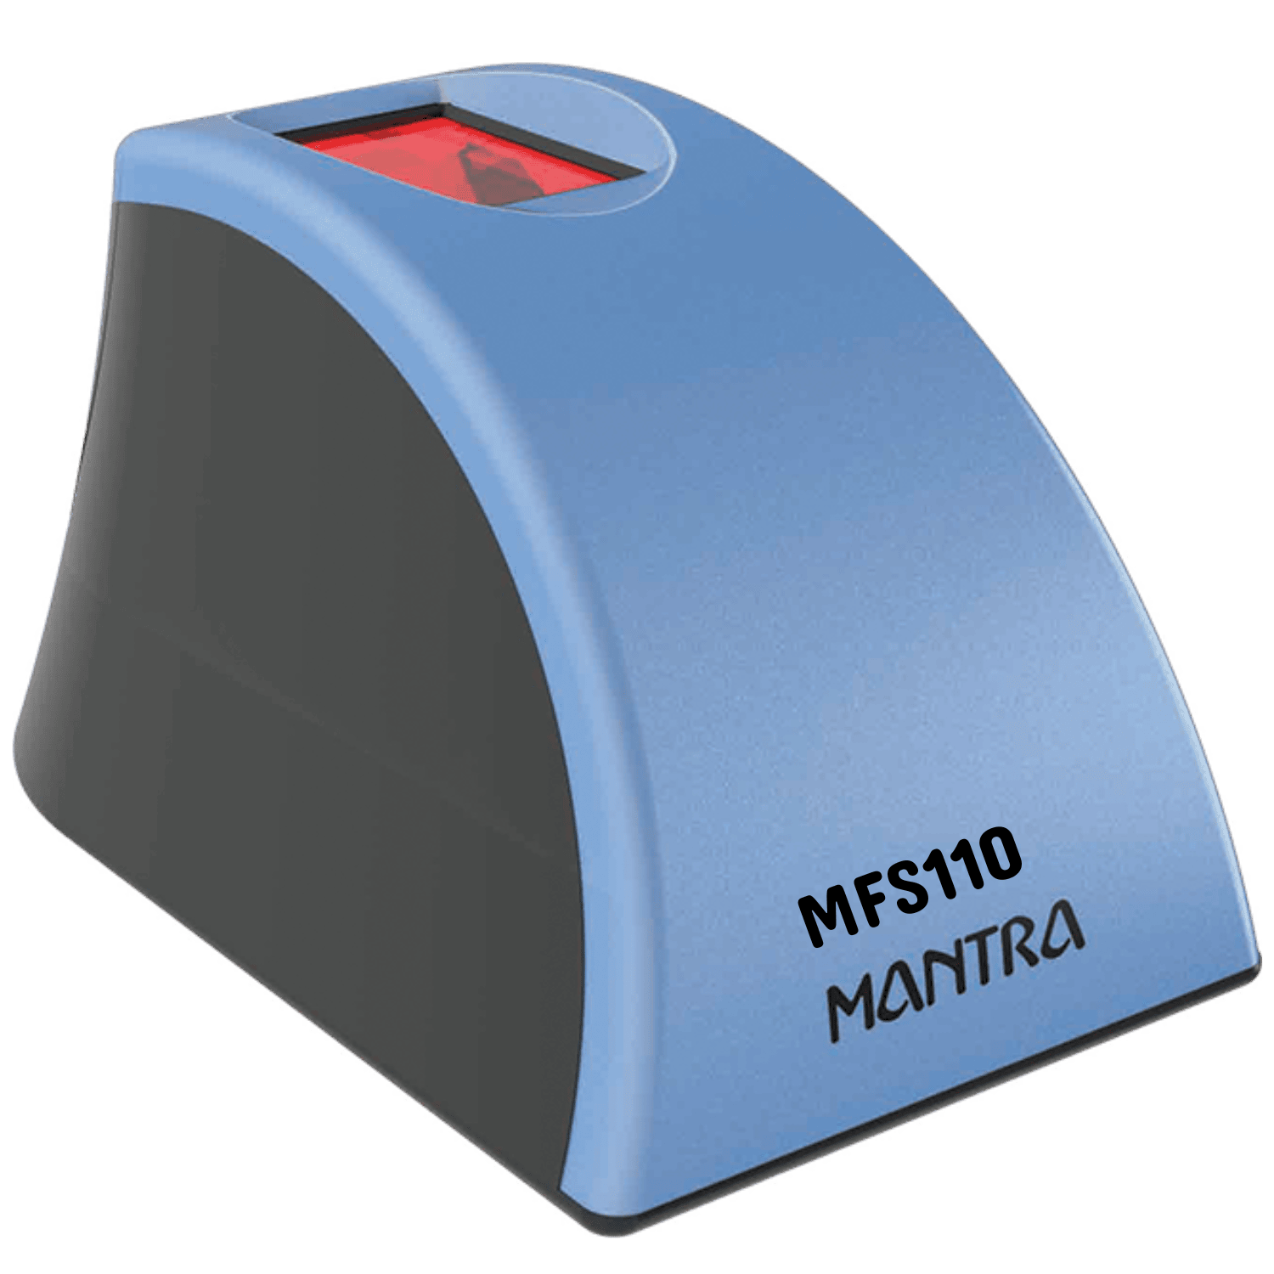

fig:3.4.1.1 Mantra RD MFS110

3.4.2 Software Requirements
- Operating System: Windows 10/11.
- Programming Languages: Python, HTML&CSS
- Libraries / Frameworks:
ECDSA, cryptography → ECC operations
Hash lib → hashing biometric data
Flask → backend API
The system requires the following software components
Operating System (OS)
The system is designed to run on Windows 10/11, providing a stable and secure environment for development and execution. These operating systems support necessary drivers for biometric devices and ensure compatibility with modern software tools. They also offer built-in security features like Windows Defender and regular updates, enhancing system protection. Additionally, Windows provides a user-friendly interface and broad hardware support, making deployment easier.
Programming Languages
Python
Python is used as the primary programming language for developing the system due to its simplicity and readability. It supports powerful libraries for cryptography, biometric processing, and data handling, making implementation easier. Python also enables rapid development and testing of security algorithms like ECC and ECDSA. Additionally, its cross-platform compatibility ensures smooth integration with different systems and devices.
HTML & CSS
The frontend of the system is developed using HTML and CSS. HTML is responsible for structuring the web pages by defining elements such as forms, buttons, input fields, and file upload sections. It enables user interaction through login pages, 31 document upload interfaces, and slot booking modules. CSS is used to enhance the visual appearance of the application by applying styles such as colours, fonts, layouts, and spacing. Advanced CSS features like Flexbox, Grid, and media queries are used to create a responsive design that works efficiently on both mobile and desktop devices. This combination ensures a clean, user-friendly, and interactive interface, improving usability and accessibility.
Libraries
ECDSA: ECDSA (Elliptic Curve Digital Signature Algorithm) is used as a cryptographic library to provide secure digital signatures for authentication. It enables the system to verify user identity by signing and validating data using elliptic curve keys. ECDSA ensures data integrity, authenticity, and non-repudiation during communication. Additionally, it offers strong security with smaller key sizes, making it efficient for mobile and cloud-based applications.
Cryptography: Cryptography is used to secure data by converting it into an unreadable format, ensuring confidentiality and protection from unauthorized access. It plays a key role in authentication by verifying user identity and maintaining data integrity. In this system, cryptographic techniques like ECC and digital signatures are used to provide secure communication. It also helps prevent attacks such as data tampering, replay attacks, and impersonation.
ECC Operation: The system uses Elliptic Curve Cryptography (ECC) for secure key generation and authentication. A private key is generated and the corresponding public key is computed using scalar multiplication (Q = d G). During login, the private key is used to create a digital signature using ECDSA. The server then verifies this signature using the public key through operations like point addition and multiplication. These ECC operations ensure strong security with efficient performance.
Hash lib
The hash lib module in Python is part of the Python Standard Library and provides a common interface for various secure hash and message digest algorithms, such as SHA-256, SHA-512, and MD5. It is used for purposes like data integrity verification, secure password storage, and digital signatures.
Flask
Flask’s minimalist and RESTful nature make it the ideal choice for this project. It provides a lightweight environment that easily integrates with Python’s heavy-duty mathematical and cryptographic libraries, ensuring that the server-side verification remains fast and scalable for cloud deployment.

3.5 Security & Threat Analysis
- Zero-Knowledge Integrity: The server never receives raw biometric data, ensuring that a "Service Provider Hack" does not result in identity theft.
- Phishing Resistance: Since there is no password to type, users cannot be tricked into entering credentials on a fake website.
- Replay Attack Protection: ECDSA uses a unique "nonce" (random number) for every signature; an intercepted signature cannot be reused by a hacker.
- Private Key Isolation: The private key is generated in the device's volatile memory (RAM) and exists only for the duration of the signing process, leaving no trace on the hard drive.
- Cryptographic Strength: A 256-bit ECC key provides a security level equivalent to a 3072-bit RSA key, making it resistant to modern brute-force attacks.
3.5.1. Performance & Efficiency Analysis
- Low Computational Overhead: ECDSA requires significantly less CPU power than RSA, which is critical for battery-powered biometric sensors.
- Reduced Bandwidth Usage: Because ECC keys and signatures are small (approx. 64 bytes), the "Handshake" between the device and the cloud is nearly instantaneous, even on slow networks.
- Storage Optimization: The Cloud Database only needs to store a 64-character string (Public Key) per user, drastically reducing server-side storage costs.
- Verification Speed: Cloud servers can verify thousands of ECDSA signatures per second, allowing the system to scale for millions of users.

3.5.2. Reliability & Biometric Analysis
- Fuzzy Tolerance: The analysis shows that the Fuzzy Extractor successfully corrects minor "noise" (e.g., a sweaty finger or slight tilt), keeping the False Rejection Rate (FRR) low.
- Entropy Density: By using SHA-256 on the biometric template, the system ensures high "entropy," meaning no two different fingers can ever generate the same key.
- Environmental Robustness: The system design accounts for sensor variations, ensuring consistent performance across different hardware brands.

4. SYSTEM DESIGN
The architecture illustrates the complete workflow of the Biometric ECC Vault, highlighting the “Zero-Knowledge” approach where sensitive private data remains within the local system and is never shared externally.
Here is a structured description you can use for your documentation:
System Architecture
Registration & Authentication
The system is divided into two distinct operational phases: The Registration Phase (Identity Creation) and the Authentication Phase (Identity Proofing).
1. Registration Phase (Identity Enrollment)
In this initial stage, the user's permanent cryptographic identity is established and bound to their biological features.
- Biometric Input: The user provides a raw biometric sample (e.g., a fingerprint scan).
- Fuzzy Extractor: This core component extracts unique features from the noisy biometric input. It generates a stable Biometric Hash and "Helper Data." The helper data allows the system to account for minor variations in future scans without storing the actual fingerprint.
- ECC Key Generation: The system derives an Elliptic Curve key pair directly from the biometric hash. The Private Key (d) is used locally, while the Public Key (Q) is prepared for the cloud.
- Cloud Server Storage: To maintain maximum privacy, the server only stores the ECC Public Key. No biometric data or private keys are ever uploaded, ensuring that a server breach does not compromise the user's biological identity.
2. Authentication Phase (Secure Access)
This phase uses a "Challenge-Response" mechanism to verify the user without needing a password.
- ECC Key Regeneration: When the user scans their finger again, the Fuzzy Extractor uses the new input and the previously stored helper data to reproduce the exact original Biometric Hash. This hash is then used to regenerate the Private Key.
- Signature Generation: Using the regenerated Private Key, the system creates a unique Digital Signature (ECDSA) for the current login session. This signature proves "possession" of the key.
- Signature Verification: The Cloud Server receives the signature and compares it against the stored Public Key.
- Validation: If the math checks out (the points on the curve align), the signature is valid.
- Access Granted: Upon successful verification, the user is redirected to the secure vault dashboard.
Key Security Advantages
- Non-Storage of Secrets: The private key is "ephemeral"—it exists in memory only during the second it takes to sign the request, then it disappears.
- Zero-Knowledge Proof: The server confirms the user's identity with 100% certainty but gains zero knowledge about the user's actual fingerprint or private key.

4.1 Design Goals
Design goals represent the qualities that the system should achieve in order to perform efficiently and effectively.
- Stateless Security: Eliminates at-rest theft by regenerating the Private Key in temporary RAM only during active scans, ensuring no secrets are stored on physical disks or cloud databases.
- Privacy-First (Local Processing): Ensures raw biometric data never leaves the user's device; the cloud server acts strictly as a verifier holding only non-sensitive Public Keys.
- Noise Resilience: Implements Fuzzy Extractor logic to successfully reconstruct cryptographic seeds despite physical variations in biometric scans, balancing low False Rejection (FRR) with near-zero False Acceptance (FAR).
- Cryptographic Integrity: Leverages ECDSA and session challenges to provide non-repudiation and prevent replay attacks, ensuring only the registered user can generate a valid signature.
- Lightweight Scalability: Utilizes ECC to provide high-grade security with smaller key sizes and optimized server-side verification (P = u1G + u2Q), reducing overhead for mobile devices and high-traffic cloud environments.
4.2 System Architecture
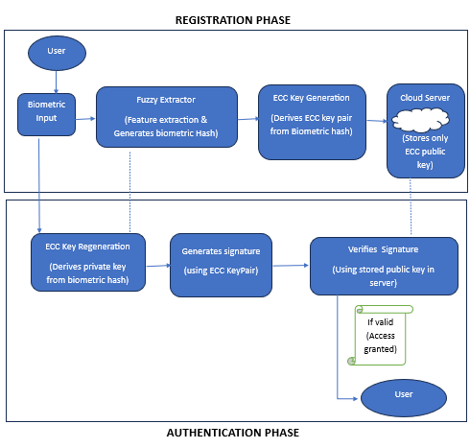
Fig: 4.2.1 System Architecture

1. The Registration Phase (The Setup)
This happens only once, when the user first signs up for the cloud service.
- Biometric Input: The user provides a raw biometric sample (e.g., a fingerprint).
- Fuzzy Extractor: This is the most critical technical piece. Since a finger touch is never 100% the same twice, the Fuzzy Extractor smooths out the "noise" and generates a consistent Biometric Hash (using SHA).
- ECC Key Generation: The system uses that stable Biometric Hash as the seed to create a mathematical Key Pair:
  - Private Key: Kept secret and derived locally.
  - Public Key: Calculated from the private key.
- Cloud Server Storage: The device sends only the Public Key to the cloud.
- Security Note: Even if the cloud server is hacked, the attacker only has the Public Key. They cannot work backward to find the user's fingerprint or the private key.
2. The Authentication Phase (The Daily Login)
This happens every time the user wants to access the cloud.
- ECC Key Regeneration: When the user scans their finger again, the Fuzzy Extractor uses the new scan to re-derive the exact same Private Key that was created during registration. The key is "born" in the device's RAM for a split second and is never stored on the hard drive.
- Generate Signature (ECDSA): Instead of sending the fingerprint to the cloud, the device uses the Private Key to "sign" a piece of data (a challenge). This produces a unique digital signature.
- Verify Signature: The signature is sent to the Cloud Server. The server uses the stored Public Key to mathematically verify that the signature was created by the matching Private Key.
- Access Granted: If the math checks out, the cloud knows the real user is present without ever having seen their actual biometric data.

4.3 System Design
1. Zero-Knowledge Storage (Privacy First)
In traditional systems, servers store a "hash" of your password. If a hacker steals that database, they can try to crack the hashes.
- The Concept: "Zero-Knowledge" means the Cloud Server knows that you are the right person, but it doesn't know what your biometric looks like.
- How it works: Your raw fingerprint image never leaves your phone or laptop. Only the ECC Public Key is sent to the cloud.
- The Benefit: Even if the Cloud Provider is compromised, the hackers find nothing but "Public Keys," which are mathematically useless without your physical finger to generate a signature.
2. Consistency (The "Fuzzy" Problem)
Unlike a password, which is always the same "string," a biometric scan changes slightly every time you touch the sensor (due to sweat, pressure, or dust). In cryptography, if even one-bit changes, the key fails.
- The Concept: The system must be Error-Tolerant while remaining Cryptographically Strict.
- How it works: This is where your Fuzzy Extractor and SHA logic come in. They use "Helper Data" to correct these minor physical variations, ensuring that the same Private Key () is reconstructed every single time.
- The Benefit: The user doesn't get locked out just because their finger is a little dry or tilted at a different angle.
3. High Efficiency (Performance)
Biometric sensors are often found on mobile phones or small IoT devices with limited battery and processing power.
- The Concept: Security should not make the device slow or drain the battery.
- How it works: This is the main reason you chose ECDSA over RSA. ECDSA provides the same level of security as RSA but with much smaller keys (256-bit vs 3072-bit). Smaller keys mean the math is faster and requires less memory.
- The Benefit: The login happens in milliseconds, providing a smooth "User Experience" (UX) that feels as fast as unlocking a phone.
4. Revocability (The "Permanent" Identity Problem)
- The Concept: You must be able to "cancel" a biometric identity if a device is lost or stolen.
- How it works: Your system links the biometric to a specific ECC Key Pair. If your phone is stolen, the Cloud Administrator simply deletes your Public Key from the server.
- The Benefit: Even though the thief has the phone (and potentially a way to spoof the biometric), the Cloud will no longer accept signatures from that specific key. You can then "Re-Register" on a new device, generating a brand new ECC key from the same finger.

4.4 UML DIAGRAMS
Unified Modelling Language (UML) is a general-purpose modelling language. The main aim of UML is to define a standard way to visualize the way a system has been designed. It is quite similar to blueprints used in other fields of engineering. UML is not a programming language; it is rather a visual language.
- We use UML diagrams to show the behaviour and structure of a system.
- UML helps software engineers, businessmen, and system architects with modelling, design, and analysis.
4.4.1 Use Case
A use case diagram is a UML visual representation that models a system’s functional requirements, showing interactions between users (actors) and system functionalities (use cases). It defines the system scope via a system boundary, focusing on what the system does rather than how. It’s ideal for outlining user goals, defining requirements, and communicating with stakeholders.
This Use Case Diagram illustrates the high-level functional requirements and the interaction between the primary actors: the User and the Cloud Server. It effectively maps the journey from initial identity enrolment to secure data access.
The diagram represents the Functional Flow of the Biometric ECC Vault, showcasing how user-side actions trigger cryptographic responses from the server.
1. Primary Actors
- User: The human entity interacting with the biometric scanner and the web interface.
- Cloud Server: The remote infrastructure responsible for storing public identities and performing mathematical verification.
2. Registration Workflow (Enrolment)
This sequence establishes the user's permanent cryptographic anchor:
- Register using Biometric: The entry point where the user provides their identity details.
- Capture Biometric / Extract Features: The system scans the fingerprint and isolates unique minutiae points.
- Generate Biometric Hash: These features are converted into a stable digital seed using fuzzy extraction math.
- Generate ECC Keys: A unique ECC key pair (Private and Public) is derived from the biometric hash.
- Store Public Key: The user sends the Public Key to the Cloud Server. Note that the Private Key remains local, ensuring the server never gains total access to the user's secret.
3. Authentication Workflow (Verification)
- This sequence allows the user to access their cloud-stored vault without a password:
- Login using Biometric: The user initiates the login request by scanning their finger.
- Generate Private Key & Signature: The system reconstructs the private key on-the-fly and creates a one-time ECDSA Signature.
- Verify Signature: The Cloud Server uses the pre-stored Public Key to mathematically validate the signature.
- Authentication Success / Access Cloud: Once the server confirms the "Zero-Knowledge" proof, the user is granted an active session to view and manage their files.
- Strategic Design Insights Local Processing: Actions like "Generate Private Key" and "Extract Features" happen on the user side. This is a critical security feature: biometric data never travels over the network.
- Server Independence: The Cloud Server is depicted as a "Verifier." It doesn't need to know the user's password; it only needs to confirm that the mathematical signature is valid.
- End-to-End Integrity: The flow from "Register" to "Access Cloud" ensures that the biological identity (the finger) is perfectly locked to the digital identity (the ECC Public Key).
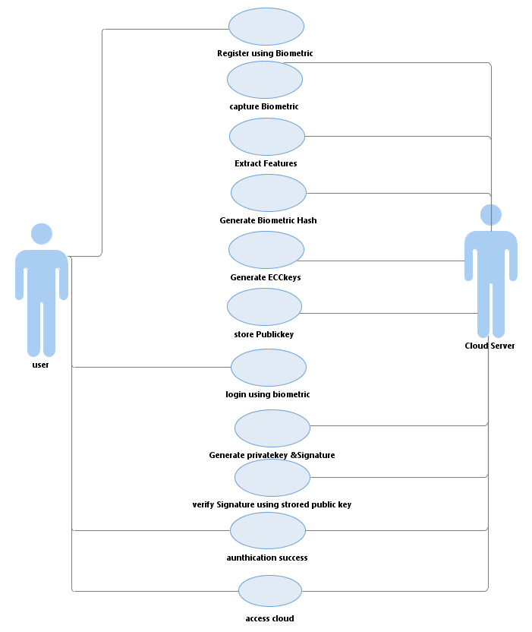
fig:4.4.1 Use Case Diagram
4.4.2 Class Diagram
A UML class diagram shows the structure of a system by displaying its classes, their attributes, methods, and the relationships between them. It helps the team understand how the system is organized and how components interact.
- Represents classes, attributes, methods, and relationships
- Helps communicate and document the software structure
- Makes it easier for developers and designers to understand the system.
This Class Diagram provides a technical blueprint of the system's Object-Oriented structure, detailing the specific attributes and methods assigned to each component. It illustrates how the biometric data is processed through various modules to achieve a secure ECC handshake.
1. User Class
The User class represents the client-side actor.
- Attributes: user ID (Unique identifier) and Biometric Data (The raw input from the sensor).
- Methods: register Biometric () for initial enrolment and request Authentication () to trigger the login sequence.
2. Fuzzy Extractor Class
This class acts as the bridge between biology and digital data.
- Attributes: biometric Template (The processed version of the input).
- Methods: capture Biometric (), extract Features (), and send Features (). Its primary role is to filter out the "noise" in a fingerprint to ensure the cryptographic key can be reconstructed consistently.
3. ECC Key Generator Class
The core of the Elliptic Curve Cryptography logic.
- Attributes: public key and private key.
- Methods: generate public key () and generate Private key (). It uses the output of the Fuzzy Extractor to derive keys on the NIST P-256 (secp256r1) curve.

4. Digital Signature Generator Class
- Responsible for proving identity without sharing secrets.
- Attributes: message (The login challenge).
- Methods: generate Signature (). It uses the derived Private Key to sign the message, creating an ECDSA signature that is unique to the current session.
5. Cloud Server Class
- The central hub for data persistence and authentication requests.
- Attributes: stored public key and authentication status.
- Methods: stored public key () (to handle registration) and authenticate User () (to orchestrate the verification process).
6. Signature Verifier Class
The final gatekeeper on the server-side.
- Attributes: verification status (Boolean result of the math).
- Methods: verify Signature (). It pulls the stored Public Key from the Cloud Server and performs the ECC mathematical check: if the signature is mathematically valid, access is granted.
Data Relationships (Multiplicity)
- 1:1 Relationships: The diagram shows a strict 1-to-1 mapping between the User, their Keys, and the Verifier. This ensures that every biometric identity is uniquely bound to exactly one cryptographic profile, preventing identity collision or credential sharing.
- Modular Coupling: The classes are interconnected in a linear pipeline, showing the "Chain of Trust" where the output of the Fuzzy Extractor is the only way to reach the ECC Key Generator, which in turn is the only way to generate a valid signature.

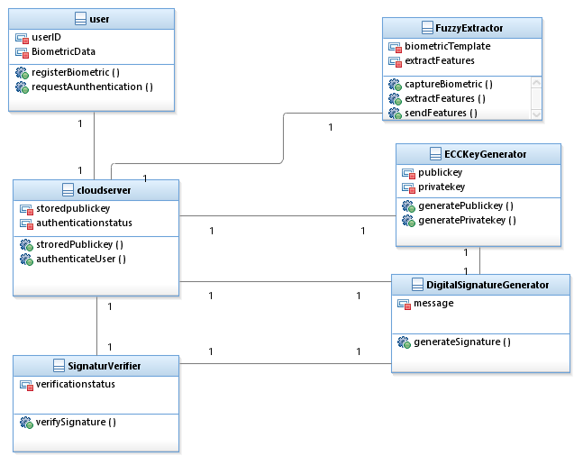
fig:4.4.2 Class Diagram

4.4.3 Activity Diagram
Activity diagram is basically a flowchart to represent the flow from one activity to another activity. The activity can be described as an operation of the system.
The control flow is drawn from one operation to another. This flow can be sequential, branched, or concurrent. Activity diagrams deal with all type of flow control by using different elements such as fork, join, etc. Activity is a particular operation of the system. Activity diagrams are not only used for visualizing the dynamic nature of a system, but they are also used to construct the executable system by using forward and reverse engineering techniques.
The purpose of an activity diagram can be described as
- Draw the activity flow of a system.
- Describe the sequence from one activity to another.
- Describe the parallel, branched and concurrent flow of the system.
These Activity Diagrams (or Flowcharts) represent the step-by-step logic for the two primary life cycles of your application: Registration (Setting up the vault) and Authentication (Accessing the vault).
1. Registration Phase Activity Flow: The Registration Phase follows a precise sequence to transform physical biometric traits into a secure, cloud-stored cryptographic identity. It begins with User Initialization, where profile details are recorded, followed by Biometric Acquisition to capture raw sensor data. This data undergoes Feature Extraction to identify unique minutiae, which are then processed via a one-way hashing algorithm to generate a stable Biometric Hash. This hash acts as a seed for ECC Key Generation, creating a Private Key for local device storage and a corresponding Public Key. Finally, the ECC Public Key is uploaded to the cloud database, establishing a permanent cryptographic "lock" that only the user’s unique biometric signature can open.
2. Authentication Phase Activity Flow: The Authentication Phase defines the decision-making logic required to grant or deny access to the secure vault. It begins when a user initiates login, triggering a fresh biometric scan that the system processes to reconstruct the original Biometric Hash via "Fuzzy Vault" logic. If successful, a temporary ECC Private Key is regenerated in volatile memory to sign a session challenge, creating an ECDSA Digital Signature. This signature is transmitted to the cloud server, where a decision logic block verifies it against the stored Public Key. If valid, access is granted to the cloud dashboard; otherwise, authentication fails, and a security alert is triggered. This "Stateless Security" model ensures the private key only exists while the biometric sensor is active, maintaining local-side processing and server-side verification.

Registration Phase
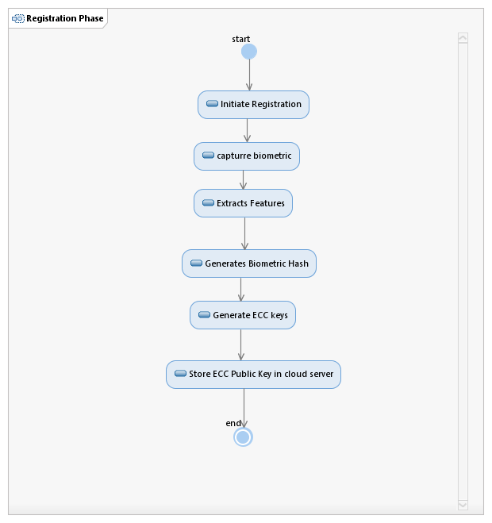
fig:4.4.3 Registration phase of Activity Diagram

Authentication Phase
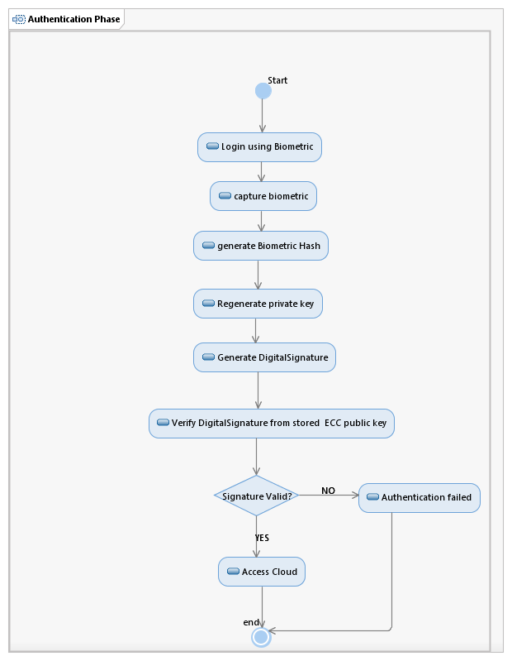
fig:4.4.3.1 Authentication phase of Activity Diagram

4.4.4 Sequence Diagram
A sequence diagram is the most commonly used interaction diagram. It simply depicts interaction between objects in a sequential order i.e. the order in which these interactions take place. We can also use the terms event diagrams or event scenarios to refer to a sequence diagram. Sequence diagrams describe how and in what order the objects in a system function. These diagrams are widely used by businessmen and software developers to document and understand requirements for new and existing systems.
Sequence diagrams can be useful references for businesses and other organizations. Purpose of sequence diagrams are:
- Represent the details of a UML use case.
- Model the logic of a sophisticated procedure, function, or operation.
- See how objects and components interact with each other to complete a process.
- Plan and understand the detailed functionality of an existing or future scenario.

Registration Phase

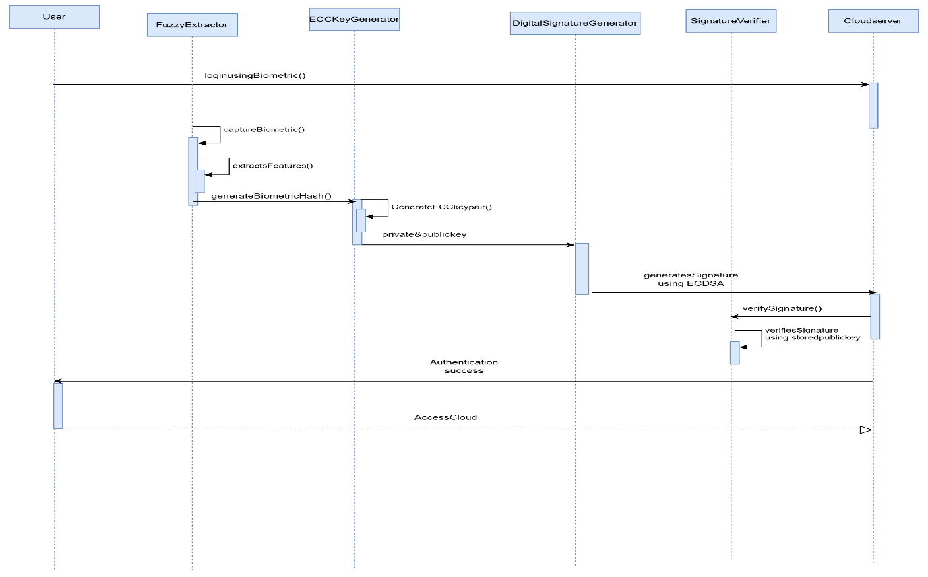
fig:4.4.4 Registration phase of Sequences Diagram

Authentication Phase
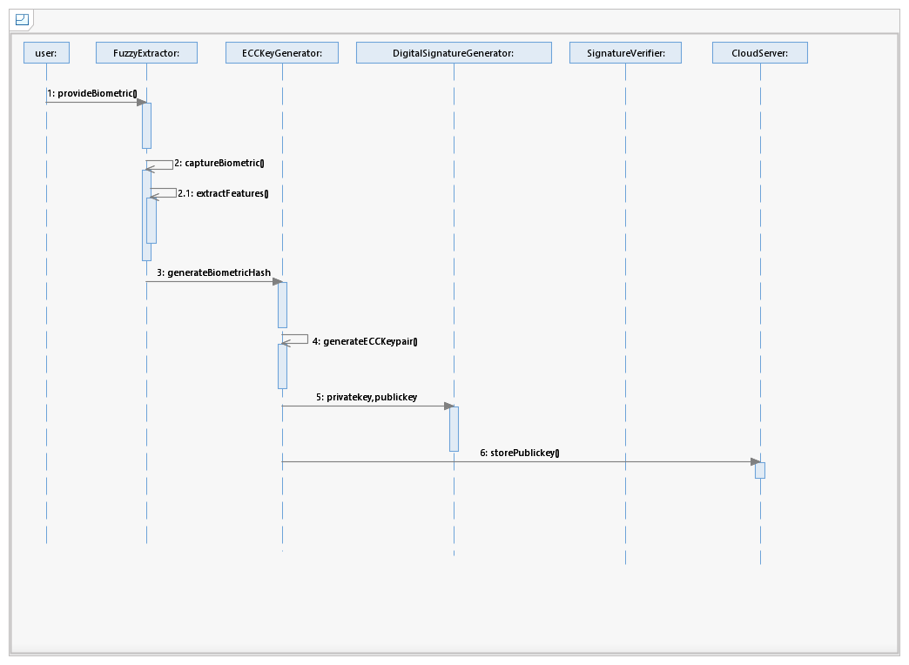
fig:4.4.4.1 Authentication phase of Sequences Diagram

5. IMPLEMENTATION
5.1 System Workflow
The system follows a structured workflow consisting of two main stages: Registration and Authentication.
- During the registration phase, the user provides a biometric input such as a fingerprint. This input is processed using a fuzzy extractor to generate a stable biometric template. The template is then hashed using the SHA-256 algorithm to produce a fixed-length secure value. This value is used to generate an ECC key pair, where the public key is stored in the cloud server and the private key is not stored permanently.
- During the authentication phase, the cloud server generates a random challenge. The user provides biometric input again, which reconstructs the private key dynamically. This private key is used to sign the challenge using the ECDSA algorithm. The generated signature is sent to the server, which verifies it using the stored public key. If the verification is successful, access is granted.

5.2 Biometric Feature Extraction Module
5.2.1 Biometric Acquisition and Feature Extraction
This phase captures the user’s biometric data and converts it into a digital format.
- Sensor Integration: A fingerprint scanner is used to capture biometric input.
- Feature Extraction: Unique features such as ridge endings and bifurcation points are extracted.
- Preprocessing: Noise reduction, normalization, and alignment techniques are applied to improve accuracy.
This phase ensures reliable biometric input for further processing.
5.2.2 Fuzzy Extractor Framework
Biometric inputs are inherently noisy and may vary slightly each time. The fuzzy extractor ensures consistency.
- During registration, the biometric data is converted into a stable secret value (R) along with helper data (P).
- During authentication, the helper data is used to reconstruct the same secret value even if there are minor variations in biometric input.
This ensures that the same cryptographic key can be derived every time.
5.2.3 ECC Key Generation
This phase generates a secure key pair using elliptic curve cryptography.
- The biometric-derived hash is converted into a private key (d).
- The public key (Q) is generated using elliptic curve point multiplication. Core equation:$Q=d×G$
- The private key remains on the client side and is never stored permanently.
- The public key is securely stored in the cloud database.
5.2.4 Stateless Authentication and Digital Signing
This phase ensures secure authentication without storing sensitive data.
- The server generates a random challenge (nonce).
- The client reconstructs the private key using biometric input.
- The private key is used to generate a digital signature using ECDSA.
- The private key exists only temporarily in memory and is erased after use.
This stateless approach ensures that no sensitive data is stored or transmitted.
5.2.5 Cloud-Side Verification and Access Control
The server verifies the authenticity of the user.
- The server retrieves the stored public key.
- The received signature is verified using ECC verification equations.
- If the signature is valid, the user is authenticated.
- A secure session is created, allowing access to the system.

5.3 Implementation Tools and Technologies
The implementation of the proposed system utilizes a combination of modern programming languages, frameworks, and libraries to ensure high performance, strong security, and ease of development.
Programming Language: Python
Python is used as the primary backend programming language due to its simplicity, readability, and extensive library support. It provides powerful built-in modules for cryptography, data processing, and system integration. Python also enables rapid development and testing of complex algorithms such as ECC and ECDSA, making it highly suitable for security-based applications.
Framework: Flask
Flask is a lightweight and flexible web framework used to build the backend server of the application. It handles HTTP requests, manages routing, and facilitates communication between the client and server. Flask’s minimalistic design allows easy integration with cryptographic libraries and supports the development of RESTful APIs required for authentication processes.
Cryptographic Libraries: ECDSA, Cryptography
The ECDSA library is used to implement elliptic curve digital signature operations, including key generation, signing, and verification. It ensures secure authentication by providing data integrity and non-repudiation.
The Cryptography library offers a wide range of cryptographic functions such as encryption, decryption, and secure key handling. Together, these libraries enable the implementation of robust and efficient ECC-based security mechanisms.
Frontend: HTML and CSS
HTML and CSS are used to design the user interface of the system. HTML structures the web pages by defining elements such as forms, input fields, and buttons, while CSS enhances the visual appearance through styling, layout design, and responsiveness. This combination ensures a user-friendly and interactive interface for registration and authentication.
Biometric Processing: Mantra RD Service
The system uses the Mantra RD (Registered Device) Service for biometric authentication. The RD service captures fingerprint data securely and performs preprocessing, encryption, and feature extraction internally. Since the biometric data is processed within the device and not exposed as raw images, it ensures high security and compliance with standards. This eliminates the need for external image processing libraries like OpenCV.
Hashing: SHA-256 (hashlib)
The SHA-256 algorithm, implemented using Python’s hashlib module, is used to convert biometric data into a fixed-length secure hash. This ensures data integrity and prevents direct exposure of biometric information. The generated hash serves as the basis for ECC key generation, providing a high level of security through strong one-way encryption.

5.4 Database Design
The system follows a privacy-preserving database design.
The cloud database stores only:
- User ID
- Public Key
- Registration Timestamp
- Authentication Logs
No biometric data or private keys are stored, ensuring a zero-knowledge architecture.

6.TESTING
The testing phase focuses on validating the Accuracy and Security of the biometric-cryptographic flow. Functional testing ensures that the SHA-256 hash and ECC key pairs are generated correctly, while integration testing verifies the seamless communication between the client and the cloud. Security testing specifically targets the system's resistance to Replay Attacks and measures the False Acceptance Rate (FAR) to ensure unauthorized access is blocked. Finally, performance testing is conducted to guarantee low-latency authentication, ensuring the passwordless process is both faster and more secure than traditional methods.
6.1 Testing Activities
Testing a large system is a complex activity and like any complex activity. It has to be broke into smaller activities. Thus, incremental testing was performed on the project i.e., components and subsystems of the system were tested separately before integrating them to form the subsystem for system testing.

6.2 Testing Types
6.2.1 Unit Testing
Validates that individual component like SHA-256 hashing, ECC key generation, and the Fuzzy Extractor function correctly in isolation. It ensures that a specific biometric input consistently produces the same cryptographic hash and mathematically valid key pairs.
6.2.2 Integration Testing
Tests the end-to-end communication between the Client Device and the Cloud Server. It verifies that the digital signature generated by the device is correctly received and successfully interpreted by the server's verification logic.
6.2.3 Performance Testing
Measures the overall Latency and resource consumption of the authentication process. It ensures that the ECC calculations are fast enough for a seamless login and do not excessively drain the mobile device's battery or CPU.
6.2.4 Security & Penetration Testing
Identifies system vulnerabilities by simulating Replay Attacks and measuring the False Acceptance Rate (FAR) and False Rejection Rate (FRR). This proves the system can block unauthorized users while reliably recognizing legitimate biometric owners.
6.2.5 User Acceptance Testing (UAT)
Evaluates the real-world usability of the passwordless framework. It confirms that the biometric authentication experience is faster, more intuitive, and more convenient for the end-user than traditional password-based methods.

6.3 Test Case
Phase 1: Identity & Public Key Verification

Test Case ID | Description | Input | Expected Result
TC-1.1 | Valid User Login | Correct Username + Matching .pub key | UI hides Phase 1, shows User Profile and Phase 2.
TC-1.2 | Invalid Username | Username not in database | Error: "User not found" or "Identity mismatch."
TC-1.3 | Key Mismatch | Valid Username + Wrong Public Key | Error: "Public key does not match record."
TC-1.4 | File Upload | Upload a valid .pub file | Text area should automatically populate with the file content.

Table 6.3.1 Identity & Public Key Verification

Phase 2: Biometric Capture & Key Reconstruction

Test Case ID | Description | Input | Expected Result
TC-2.1 | RD Service Offline | Scanner disconnected or service stopped | Error: "Scanner Error. Check RD Service."
TC-2.2 | Successful Scan | Valid finger placed on scanner | "Fingerprint Captured " and "Verify" button enables.
TC-2.3 | Biometric Mismatch | Valid User but wrong finger used | Error: "Biometric Data Mismatch" (Private key cannot be reconstructed).
TC-2.4 | Reconstruction | Valid finger + Valid Session | UI transitions to Phase 3 (Digital Signature Proof).

Table 6.3.2 Biometric Capture & Key Reconstruction

Phase 3: ECDSA Signature & Authorization

Test Case ID | Description | Input | Expected Result
TC-3.1 | Valid Signature | Click "Authorize" with valid session | Visual signature string appears in green box; redirect to Dashboard.
TC-3.2 | Session Timeout | Wait 10 secs (if backend has timeout) | Error: "Session expired or User ID missing."
TC-3.3 | Direct URL Access | Type /dashboard in browser without login | Backend should redirect user back to login (Access Denied).
TC-3.4 | Missing User ID | Manually clear local Storage then click sign | Fail-Safe trigger: Alert "User ID Missing" and auto-redirect to Phase 1.

Table 6.3.3 ECDSA Signature & Authorization

7.RESULTS
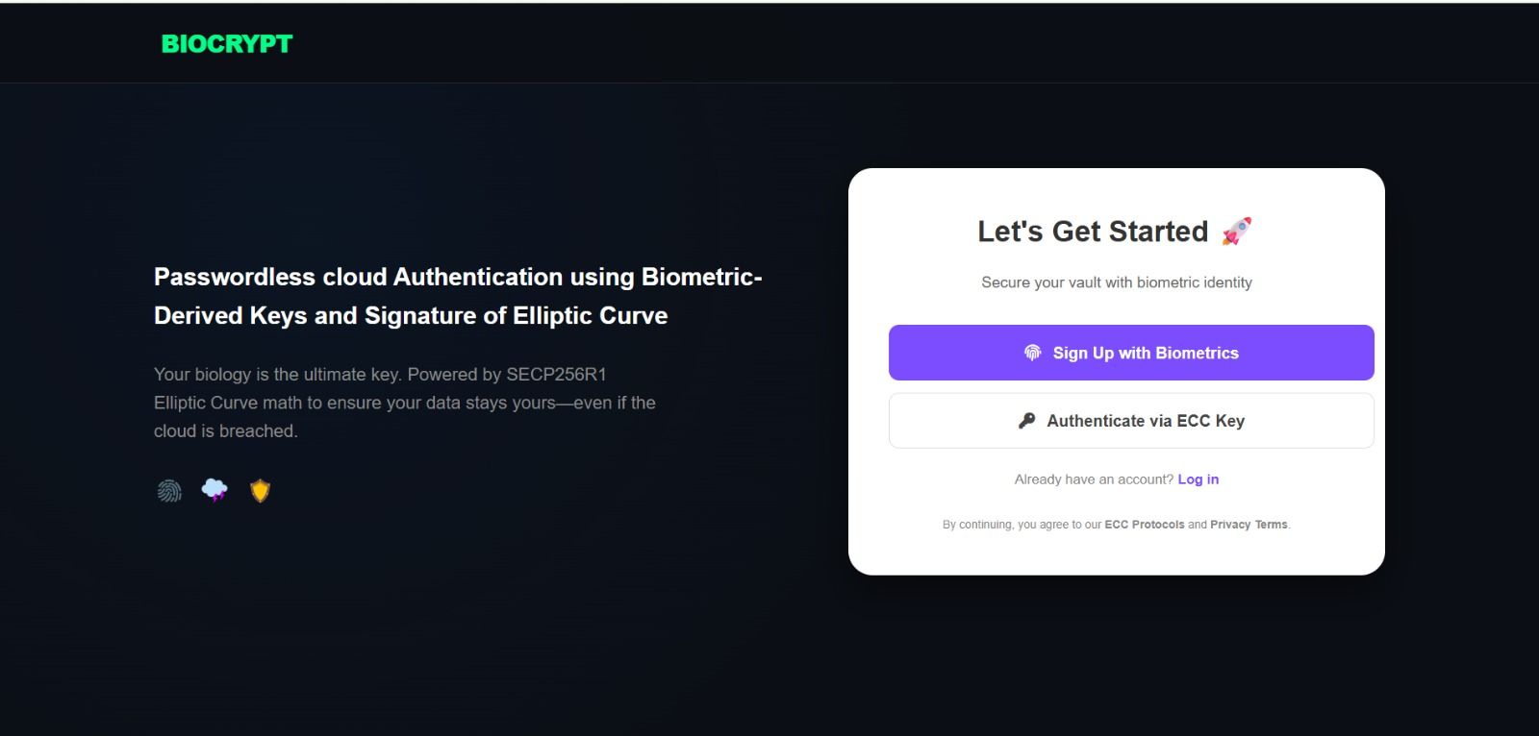
fig:7.1 Index page

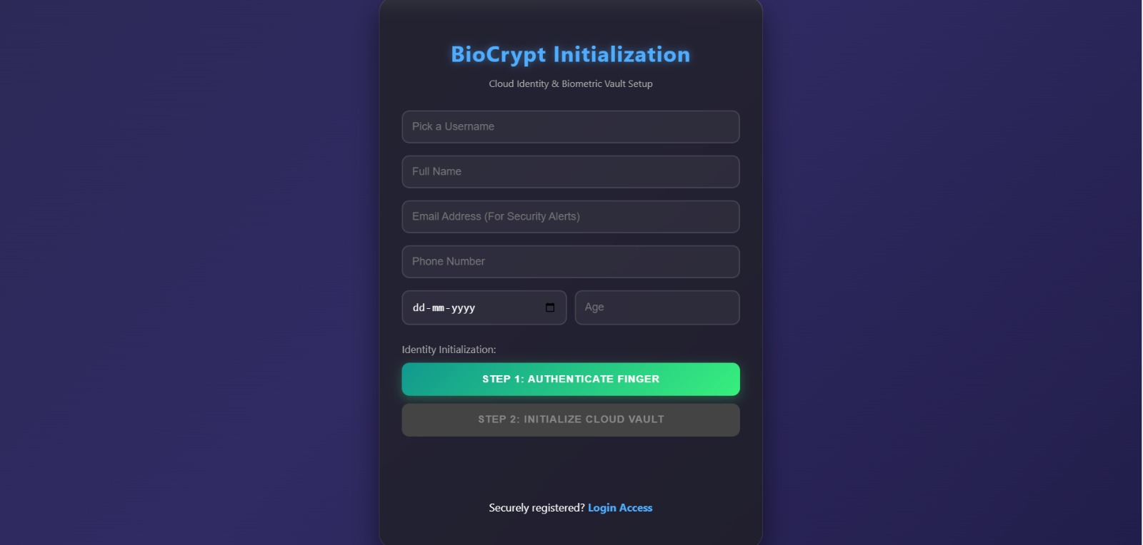

fig:7.2 Register page
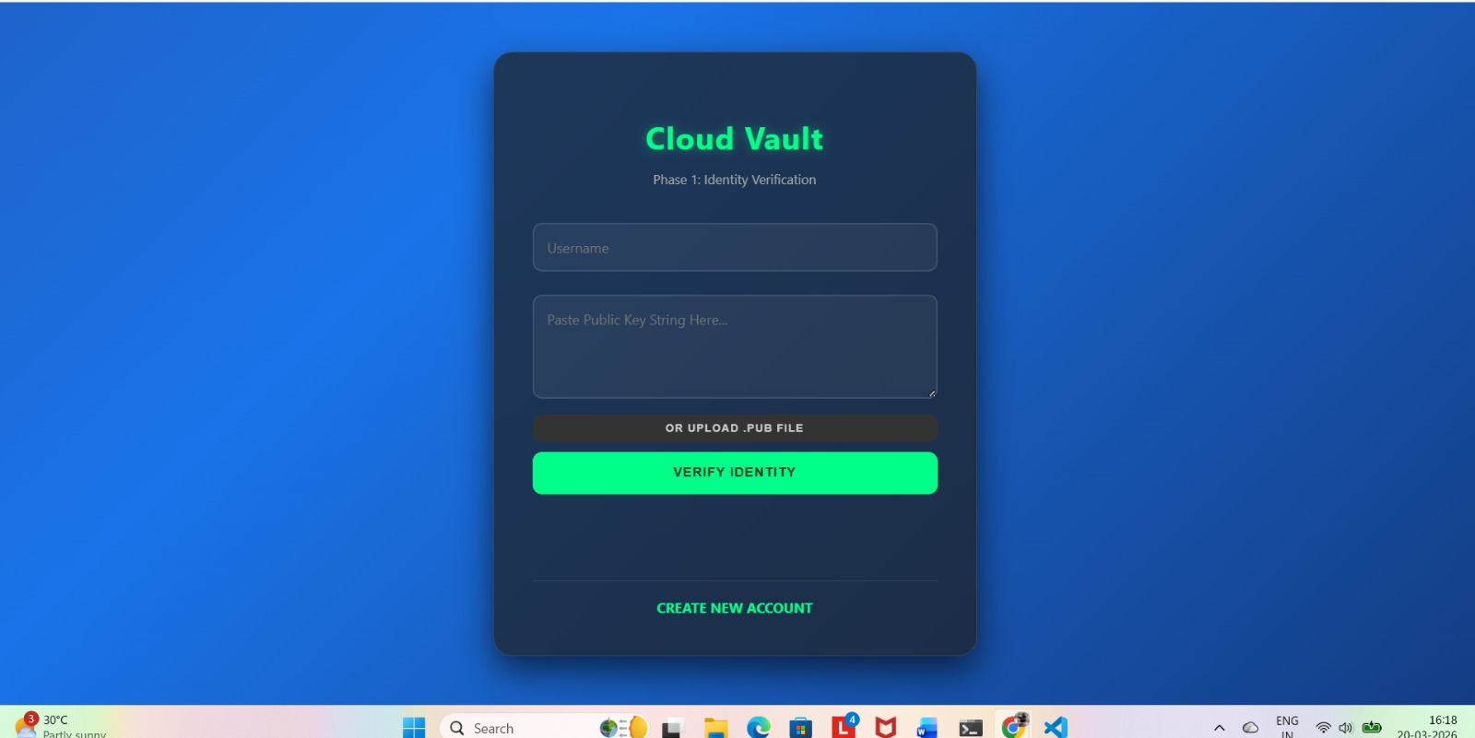

fig:7.3 Login Page

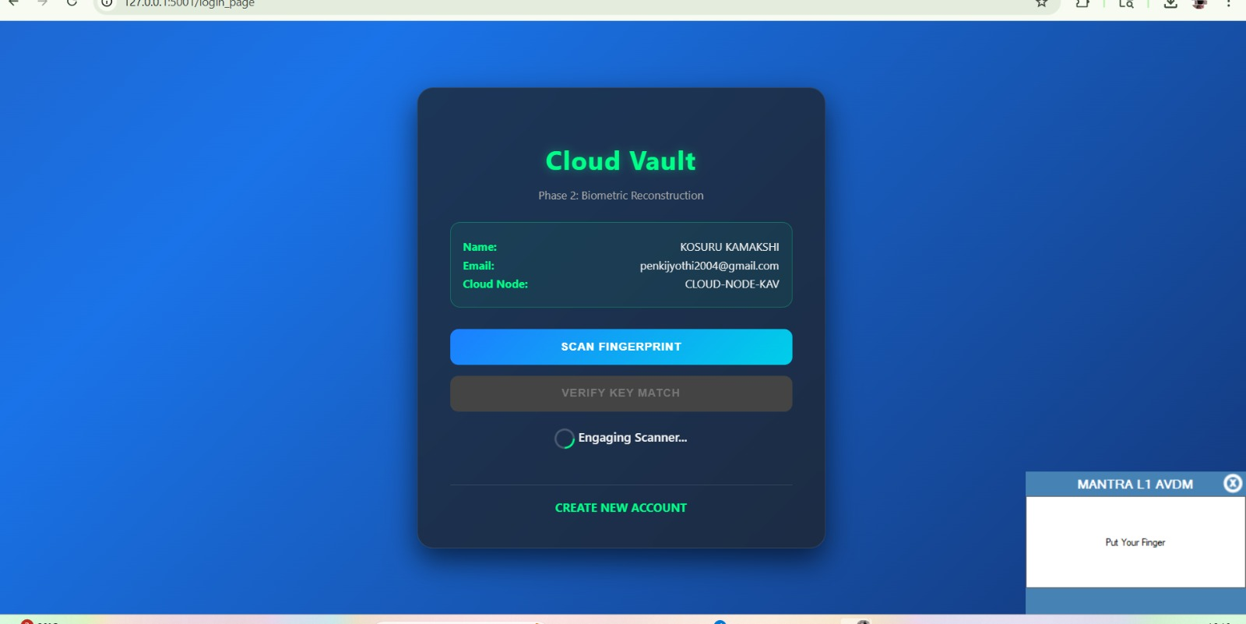

fig:7.3.1 Login Page Fingerprint Verification
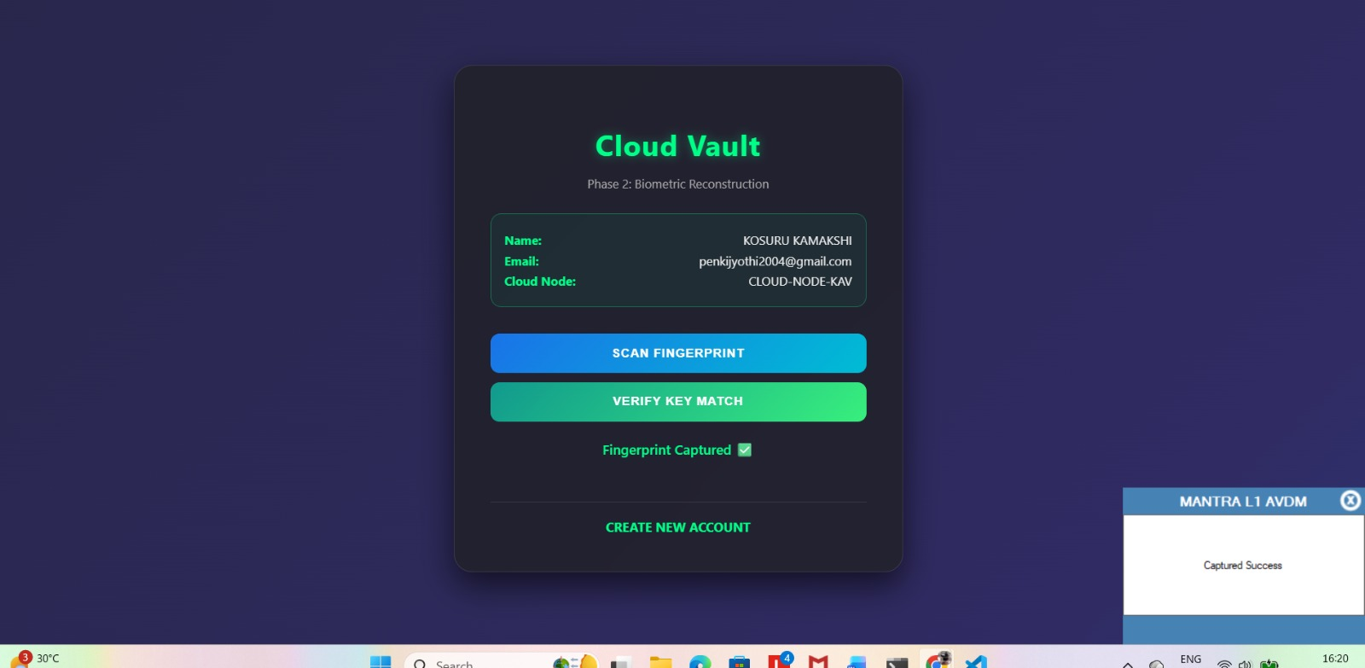

fig:7.3.2 Login Page key match verification

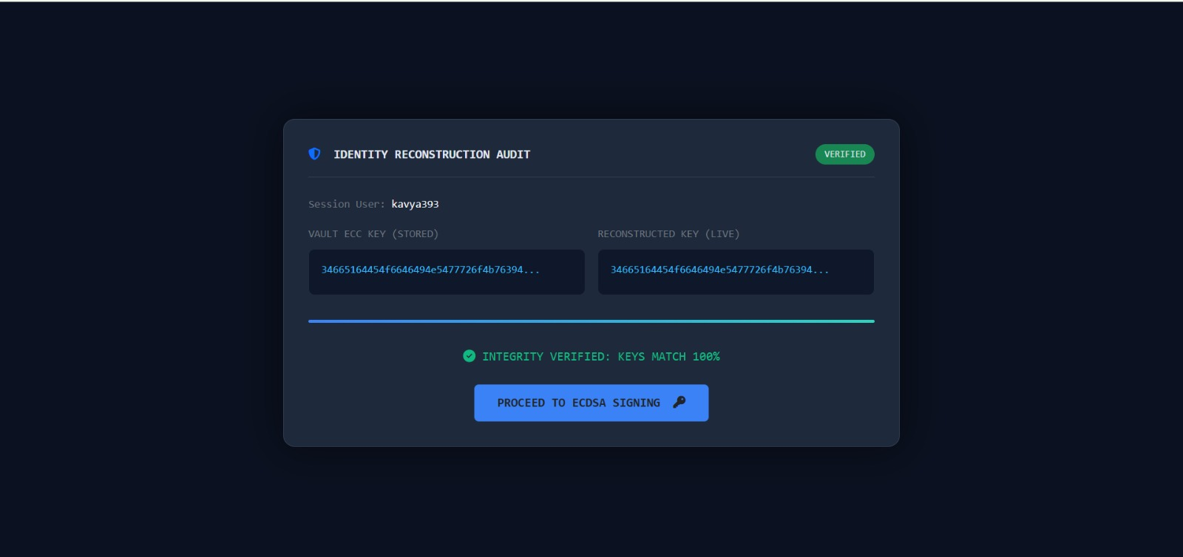

fig:7.3.3 Private Key Verification
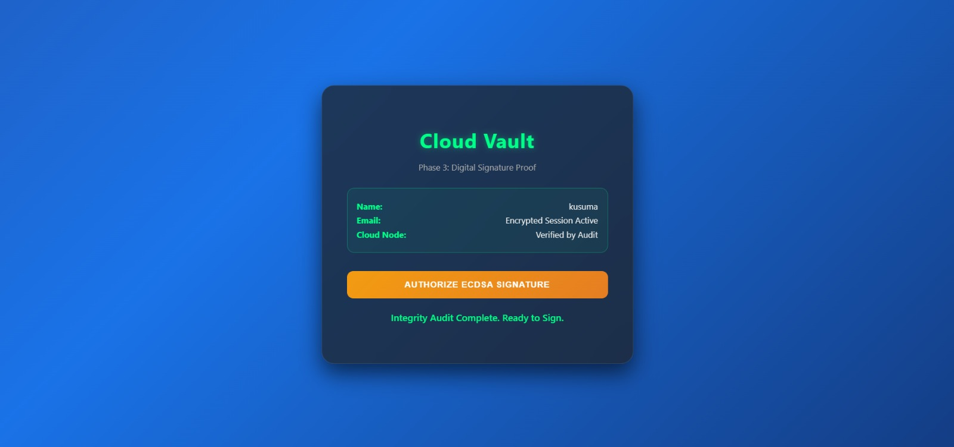

fig:7.3.4 Login Page ECDSA Signature Authorization

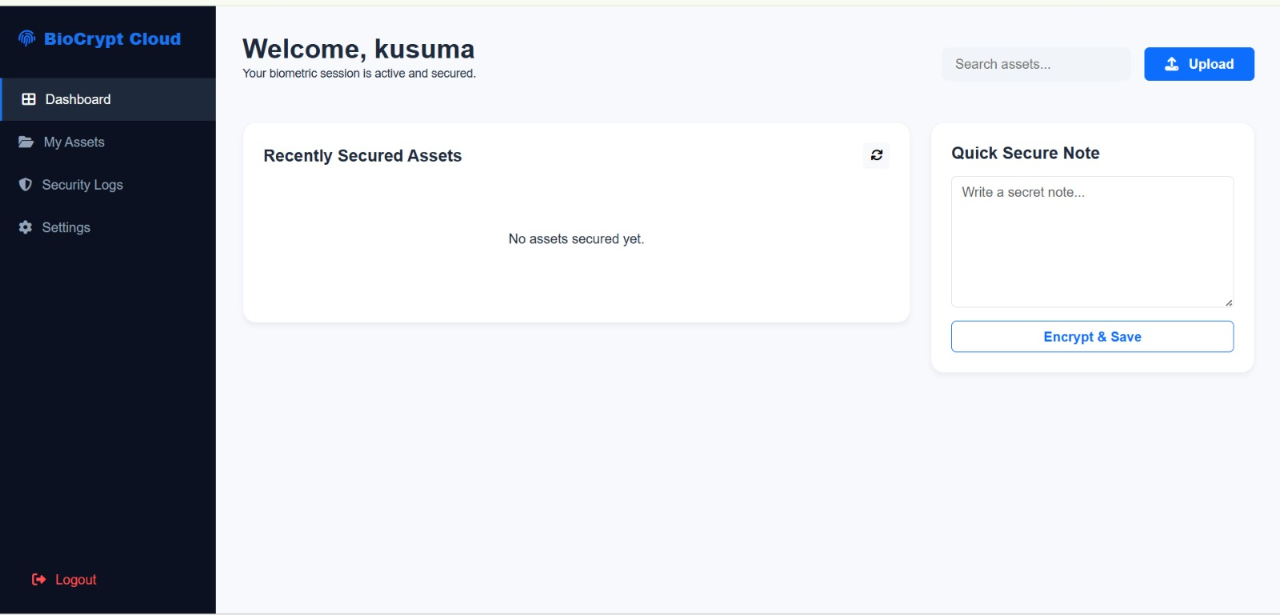

fig:7.4 Dashboard of User
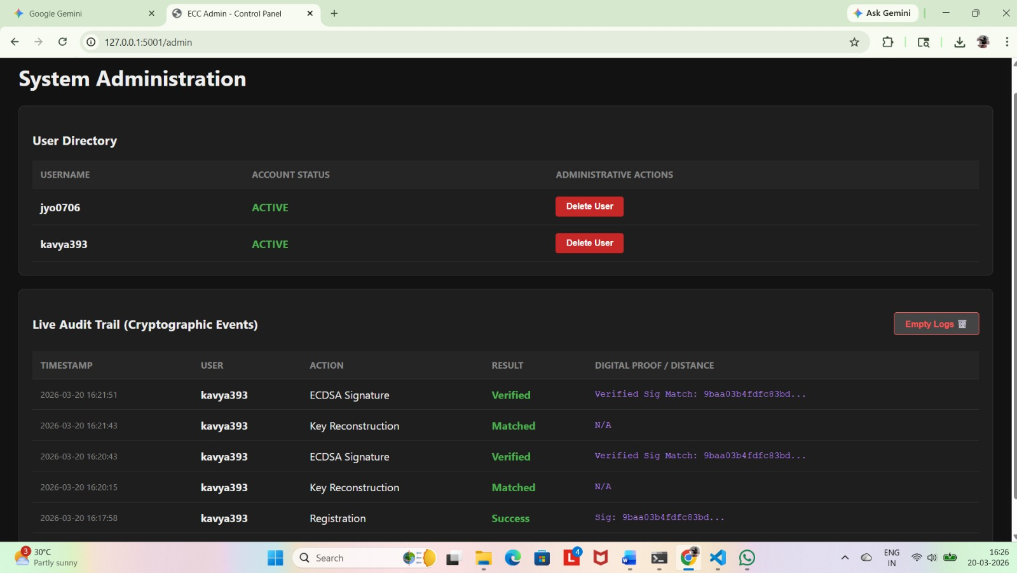

fig:7.5 System Admin Page

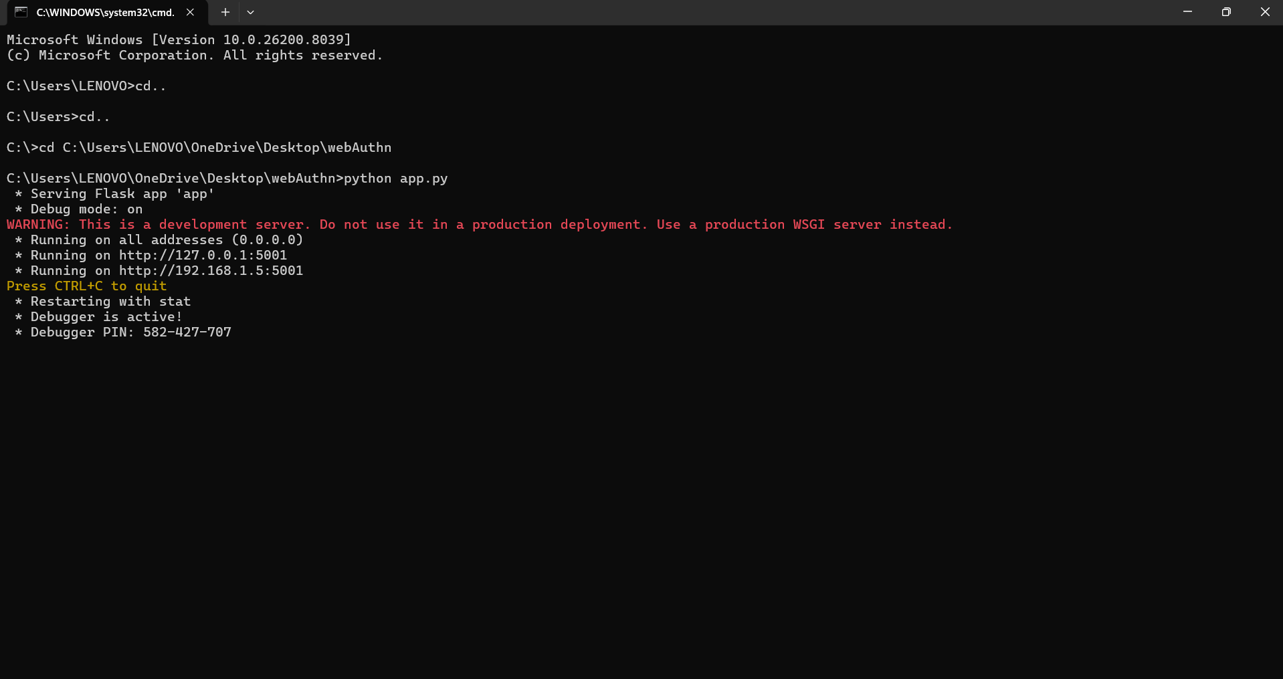

fig:7.6 Flask Server

8.SAMPLE CODE

8.1 Code for index.html

<!DOCTYPE html>
<html lang="en">
<head>
<meta charset="UTF-8">
<meta name="viewport" content="width=device-width, initial-scale=1.0">
<title>BioCrypt | Vault</title>
<style>
:root { --p: #00ff88; --b: #0b0e14; --c: #fff; }
body { margin: 0; font-family: sans-serif; background: var(--b); color: var(--c); line-height: 1.5; }
nav { padding: 20px 5%; border-bottom: 1px solid #222; color: var(--p); font-weight: 800; }
.hero { display: flex; flex-wrap: wrap; padding: 50px 5%; align-items: center; min-height: 80vh; gap: 40px; }
.hero-text { flex: 1; min-width: 300px; }
.hero-text h1 { font-size: 3rem; margin: 0; }
.auth-card { flex: 1; min-width: 300px; max-width: 400px; background: white; color: #222; padding: 30px; border-radius: 20px; text-align: center; }
.btn { display: block; padding: 12px; margin: 10px 0; border-radius: 8px; text-decoration: none; font-weight: 600; transition: 0.3s; }
.btn-p { background: #7c4dff; color: white; }
.btn-s { border: 1px solid #ddd; color: #444; }
.features { display: grid; grid-template-columns: repeat(auto-fit, minmax(200px, 1fr)); gap: 20px; padding: 50px 5%; background: #0d1117; }
.f-card { padding: 20px; border-radius: 15px; background: rgba(255,255,255,0.05); border: 1px solid #222; }
.f-card h3 { color: var(--p); margin-top: 0; }
footer { text-align: center; padding: 30px; font-size: 0.8rem; color: #444; }
</style>
</head>
<body>
<nav>BIOCRYPT</nav>
<section class="hero">
<div class="hero-text">
<h1>Zero-Knowledge Storage</h1>
<p>Secure biology-based encryption using SECP256R1 Elliptic Curve math.</p>
</div>
<div class="auth-card">
<h2>Get Started </h2>
<p>Secure your vault via biometrics</p>
<a href="/register_page" class="btn btn-p">Fingerprint Sign Up</a>
<a href="/login_page" class="btn btn-s">ECC Key Auth</a>
<div style="font-size: 0.8rem; margin-top: 15px; color: #888;">
Already have an account? <a href="/login_page" style="color:#7c4dff">Log in</a>
</div>
</div>
</section>
<section class="features">
<div class="f-card"><h3>Fuzzy Extraction</h3><p>Noise-tolerant biological entropy.</p></div>
<div class="f-card"><h3>SEC256R1</h3><p>NIST-standard private key protection.</p></div>
<div class="f-card"><h3>Zero-Knowledge</h3><p>We verify, but we never see your data.</p></div>
</section>
<footer>&copy; 2026 BioCrypt Technologies.</footer>
</body>
</html>

8.2 Code for Register.html

<!DOCTYPE html>
<html lang="en">
<head>
<meta charset="UTF-8">
<meta name="viewport" content="width=device-width, initial-scale=1.0">
<title>BioCrypt | Login</title>
<style>
:root { --accent: #4facfe; --bg: #0b0e14; }
body { font-family: sans-serif; background: var(--bg); color: #fff; display: flex; justify-content: center; align-items: center; min-height: 100vh; margin: 0; }
.card { background: rgba(30,30,30,0.8); backdrop-filter: blur(10px); padding: 30px; border-radius: 20px; width: 350px; border: 1px solid #333; text-align: center; }
input { width: 100%; padding: 12px; margin: 10px 0; border-radius: 8px; border: 1px solid #444; background: #000; color: #fff; box-sizing: border-box; }
button { width: 100%; padding: 12px; border: none; border-radius: 8px; background: var(--accent); color: #fff; font-weight: bold; cursor: pointer; transition: 0.3s; }
button:disabled { background: #444; }
#msg { margin-top: 15px; font-size: 0.9em; }
.spinner { display: inline-block; width: 14px; height: 14px; border: 2px solid #fff3; border-top-color: #fff; border-radius: 50%; animation: s 0.6s linear infinite; }
@keyframes s { to { transform: rotate(360deg); } }
</style>
</head>
<body>
<div class="card">
<h2>Vault Access</h2>
<p style="color:#888; font-size: 0.8em;">Authenticate via ECC Public Key</p>
<form id="logForm">
<input type="text" id="user" placeholder="Username" required>
<input type="file" id="keyFile" accept=".pub" required style="font-size: 0.7em;">
<button type="submit" id="logBtn">Decrypt Vault</button>
</form>
<div id="msg"></div>
<p style="font-size: 0.8em; margin-top: 20px;">No account? <a href="/register_page" style="color:var(--accent); text-decoration:none;">Register</a></p>
</div>
<script>
const $ = id => document.getElementById(id);
$('logForm').onsubmit = async (e) => {
e.preventDefault();
const btn = $('logBtn');
const msg = $('msg');
const file = $('keyFile').files[0];
btn.disabled = true;
msg.innerHTML = '<span class="spinner"></span> Verifying Identity...';
const reader = new FileReader();
reader.onload = async (event) => {
try {
const res = await fetch('/login', {
method: 'POST',
headers: {'Content-Type': 'application/json'},
body: JSON.stringify({
username: $('user').value,
public_key: event.target.result
})
});
const data = await res.json();
if (data.status === "Success") {
msg.style.color = "#00ff88";
msg.innerHTML = "Access Granted. Redirecting...";
setTimeout(() => window.location.href = "/dashboard", 1000);
} else throw data.reason;
} catch (err) {
msg.style.color = "#ff4d4d";
msg.innerHTML = "Error: " + err;
btn.disabled = false;
}
};
reader.readAsText(file);
};
</script>
</body>
</html>

8.3 Code for login.html

<!DOCTYPE html>
<html lang="en">
<head>
<meta charset="UTF-8"><meta name="viewport" content="width=device-width,initial-scale=1">
<title>BioVault</title>
<style>
body{font:14px sans-serif;background:#0f0c29;color:#eee;display:flex;justify-content:center;align-items:center;min-height:100vh;margin:0}
.c{background:#1e1e1e;padding:25px;border-radius:15px;width:320px;text-align:center;border:1px solid #333}
input,textarea{width:100%;padding:10px;margin:5px 0;background:#000;color:#fff;border:1px solid #444;border-radius:5px;box-sizing:border-box}
button{width:100%;padding:10px;margin-top:8px;border:none;border-radius:5px;font-weight:700;cursor:pointer;background:#00ff88;color:#003}
#p,#s3,#s2,#sig{display:none}
.spin{display:inline-block;width:12px;height:12px;border:2px solid #fff3;border-top-color:#00ff88;border-radius:50%;animation:s .8s linear infinite}
@keyframes s{to{transform:rotate(360deg)}}
</style>
</head>
<body>
<div class="c">
<h3 id="h">Phase 1: Identity</h3>
<div id="p" style="font-size:11px;margin-bottom:10px">ID: <span id="pn"></span> | Node: <span id="pc"></span></div>
<div id="s1">
<input id="u" placeholder="User"><textarea id="k" placeholder="Key string..."></textarea>
<button onclick="v1()">Verify ID</button>
</div>
<div id="s2"><button onclick="cap()">Scan Finger</button><button id="vb" disabled onclick="v2()" style="background:#1a73e8;color:#fff">Match Key</button></div>
<div id="s3"><button onclick="v3()" style="background:#e67e22;color:#fff">Sign & Enter</button></div>
<div id="sig" style="font:9px monospace;color:#00ff88;margin-top:10px;word-break:break-all"></div>
<div id="m" style="margin-top:10px;font-size:12px"></div>
</div>
<script>
const $=i=>document.getElementById(i), post=(u,b)=>fetch(u,{method:'POST',headers:{'Content-Type':'application/json'},body:JSON.stringify(b)});
let cd="", fk="";

const sw=n=>{['s1','s2','s3'].forEach((s,i)=>$(s).style.display=i+1==n?'block':'none');$('h').innerText=`Phase ${n}`};

async function v1(){
$('m').innerHTML='<span class="spin"></span>';
try{
const r=await post('/get_user_details',{username:$('u').value,public_key:$('k').value}), d=await r.json();
if(d.status==='success'){fk=$('k').value;$('pn').innerText=d.name;$('pc').innerText=d.cloud_id;$('p').style.display='block';sw(2);$('m').innerText=""}
}catch(e){$('m').innerText="Error"}
}
async function cap(){
$('m').innerHTML='<span class="spin"></span>';
try{
const r=await fetch("http://127.0.0.1:11100/rd/capture",{method:'CAPTURE',body:'<PidOptions ver="1.0"><Opts fCount="1" fType="2" format="0" pidVer="2.0" timeout="10000" env="P"/></PidOptions>'});
const x=new DOMParser().parseFromString(await r.text(),"text/xml");
if(x.getElementsByTagName("Resp")[0].getAttribute("errCode")==="0"){cd=x.getElementsByTagName("Data")[0].textContent;$('vb').disabled=false;$('m').innerText="Scan OK"}
}catch(e){$('m').innerText="Sensor Fail"}
}
async function v2(){
const r=await post('/verify_match',{username:$('u').value,biometric_data:cd,public_key:fk}), d=await r.json();
d.status==='Matched'?sw(3):$('m').innerText="No Match";
}
async function v3(){
const r=await post('/verify_ecdsa',{username:$('u').value}), d=await r.json();
if(d.status==='Verified'){$('sig').style.display='block';$('sig').innerText=d.visual_signature;$('m').innerText="Vault Open!";setTimeout(()=>location.href="/dashboard",2000)}
}
</script>
</body>
</html>

8.4 Code for app.py
import json, os, uuid, datetime, time
from flask import Flask, render_template, request, jsonify, session, redirect, url_for, send_from_directory
from flask_mail import Mail, Message
from werkzeug.utils import secure_filename
from cryptography.hazmat.primitives import serialization
from core.crypto_engine import derive_keys_fuzzy, reproduce_key_fuzzy, sign_challenge, verify_challenge, generate_visual_id
app = Flask(__name__)
app.secret_key = "secure_ecc_vault_key_2026"
# Configuration
app.config.update(MAIL_SERVER='smtp.gmail.com', MAIL_PORT=465, MAIL_USE_SSL=True,
MAIL_USERNAME='penkijyothi2004@gmail.com', MAIL_PASSWORD='uaactsxphtmlkaxt')
mail, BASE_DIR = Mail(app), os.path.dirname(os.path.abspath(__file__))
DB_PATH, LOG_PATH = os.path.join(BASE_DIR, 'database.json'), os.path.join(BASE_DIR, 'admin_logs.json')
UPLOAD_FOLDER = os.path.join(BASE_DIR, 'vault_storage')
os.makedirs(UPLOAD_FOLDER, exist_ok=True)
# Helpers
def io_db(data=None):
if data is None: return json.load(open(DB_PATH)) if os.path.exists(DB_PATH) else {}
with open(DB_PATH, 'w') as f: json.dump(data, f, indent=4)

def log(u, a, s, p="N/A"):
logs = json.load(open(LOG_PATH)) if os.path.exists(LOG_PATH) else []
logs.append({"ts": datetime.datetime.now().strftime("%Y-%m-%d %H:%M"), "user": u, "action": a, "status": s, "proof": p})
with open(LOG_PATH, 'w') as f: json.dump(logs, f, indent=4)

def notify(sub, rec, name, st):
msg = Message(sub, sender=app.config['MAIL_USERNAME'], recipients=[rec])
msg.body = f"Hello {name}, Event: {st} at {datetime.datetime.now()}"
try: mail.send(msg)
except: log("SYS", "Mail Fail", "Error")
# Routes
@app.route('/')
def index(): return render_template('index.html')
@app.route('/register', methods=['POST'])
def register():
d = request.json
db = io_db()
if d['username'] in db: return jsonify({"status": "Exists"}), 400
try:
priv, pub, help_d = derive_keys_fuzzy(d['biometric_data'])
db[d['username']] = {**d, "public_key": pub, "helper_data": help_d.hex(), "vault": [], "role": "user"}
io_db(db)
log(d['username'], "Reg", "Success")
notify("Welcome", d['email'], d['full_name'], "Registered")
return jsonify({"status": "Success", "visual_signature": generate_visual_id(priv, d['username'])})
except Exception as e: return jsonify({"status": "Error", "reason": str(e)}), 400

@app.route('/verify_match', methods=['POST'])
def verify_match():
d, db = request.json, io_db()
u = db.get(d['username'])
if not u: return jsonify({"status": "404"}), 404
try:
priv = reproduce_key_fuzzy(d['biometric_data'], bytes.fromhex(u['helper_data']), 5000)
session['temp_priv'] = priv.private_bytes(serialization.Encoding.PEM, serialization. PrivateFormat.PKCS8, serialization. No Encryption()).hex()
session['audit_user'] = d['username']
return jsonify({"status": "Matched", "redirect": "/audit_screen"})
except:
log(d['username'], "Login", "Failed")
return jsonify({"status": "Error"}), 401

@app.route('/verify_ecdsa', methods=['POST'])
def verify_ecdsa():
u_id, p_hex = session.get('audit_user'), session.get('temp_priv')
db = io_db()
try:
priv = serialization.load_pem_private_key(bytes.fromhex(p_hex), None)
chal = str(uuid.uuid4())
if verify_challenge(db[u_id]['public_key'], chal, sign_challenge(priv, chal)):
session.update({'user': u_id, 'temp_priv': None})
log(u_id, "ECDSA", "Success")
notify("Login", db[u_id]['email'], u_id, "Success")
return jsonify({"status": "Verified"})
except: return jsonify({"status": "Error"}), 401

@app.route('/upload_file', methods=['POST'])
def upload():
if 'user' not in session: return "Unauthorized", 401
f = request.files['file']
fn = secure_filename(f.filename)
f.save(os.path.join(UPLOAD_FOLDER, fn))
db = io_db()
db[session['user']]['vault'].append({"type": "File", "name": fn, "date": str(datetime.datetime.now())})
io_db(db)
return jsonify({"status": "Success"})

@app.route('/get_vault')
def get_v(): return jsonify(io_db().get(session.get('user'), {}).get('vault', []))

@app.route('/logout')
def logout(): session.clear(); return redirect('/')

if __name__ == '__main__': app.run(debug=True, port=5001)

9.CONCLUSION

The successful implementation of this project demonstrates that biometric-derived keys, combined with Elliptic Curve Cryptography (ECC), provide a superior alternative to traditional password-based authentication. By utilizing SHA-256 hashing and Fuzzy Extractors, the system creates a stable and unique cryptographic identity directly from a user’s physical traits. This Zero-Knowledge approach ensures that sensitive biometric data never leaves the client device, effectively eliminating the risk of large-scale credential theft from cloud databases.
The use of biometric data ensures strong user identity verification, while ECC provides lightweight and high-level security suitable for modern cloud and IoT applications. The proposed system improves security, reduces computational overhead, and enhances user convenience by avoiding the need to remember complex passwords.
Overall, this project demonstrates that integrating biometrics with ECC is an effective approach for achieving secure, scalable, and user-friendly authentication in cloud systems. Future improvements can include multi-factor authentication enhancements and advanced biometric techniques for even higher security.

10.REFERENCES
[1] S. Li, K.-K. R. Choo, Q. Sun, W. J. Buchanan, and J. Cao, “Iot forensics: Amazon echo as a use case,” IEEE Internet Things J., vol. 6, no. 4, pp. 6487–6497, 2019.
https://doi.org/10.1109/JIOT.2019.2906946
[2] J. Gubbi, R. Buyya, S. Marusic, and M. Palaniswami, “Internet of things (iot): A vision, architectural elements, and future directions,” Future Gener. Comput. Syst., vol. 29, no. 7, pp. 1645–1660, 2013.
https://doi.org/10.1016/j.future.2013.01.010
[3] A. Botta, W. De Donato, V. Persico, and A. Pescap´e, “Integration of cloud computing and internet of things: a survey,” Future Gener. Comput. Syst., vol. 56, pp. 684–700, 2016.
https://doi.org/10.1016/j.future.2015.09.021
[4] N. Alhakbani, M. M. Hassan, M. A. Hossain, and M. Alnuem, “A framework of adaptive interaction support in cloud-based internet of things (iot) environment,” in Proc. IDCS, vol. 8729, 2014, pp. 136–146.
https://doi.org/10.1007/978-3-319-11692-1_12
[5] M. S. Hossain and G. Muhammad, “Cloud-assisted industrial internet of things (iiot)–enabled framework for health monitoring,” Comput. Networks., vol. 101, pp. 192–202, 2016.
https://doi.org/10.1016/j.comnet.2016.02.023
[6] R. Amin, N. Kumar, G. Biswas, R. Iqbal, and V. Chang, “A light weight authentication protocol for iot-enabled devices in distributed cloud computing environment,” Future Gener. Comput. Syst., vol. 78, pp. 1005–1019, 2018.
https://doi.org/10.1016/j.future.2016.11.002
[7] Q. Jiang, N. Zhang, J. Ni, J. Ma, X. Ma, and K.-K. R. Choo, “Unified biometric privacy preserving three-factor authentication and key agreement for cloud-assisted autonomous vehicles,” IEEE Trans. Veh. Technol., vol. 69, no. 9, pp. 9390–9401, 2020.
https://doi.org/10.1109/TVT.2020.3009927
[8] J. Song, Q. Zhong, W. Wang, C. Su, Z. Tan, and Y. Liu, “Fpdp: Flexible privacy-preserving data publishing scheme for smart agriculture,” IEEE Sensors J., vol. 21, no. 16, pp. 17430–17438, 2021.
https://doi.org/10.1109/JSEN.2021.3070547
[9] W. Wang, C. Qiu, Z. Yin, G. Srivastava, T. R. Gadekallu, F. Alsolami, and C. Su, “Blockchain and puf-based lightweight authentication pro tocol for wireless medical sensor networks,” IEEE Internet Things J., vol. 9, no. 11, pp. 8883–8891, 2022.
https://doi.org/10.1109/JIOT.2021.3055483
[10] S. A. Chaudhry, A. Irshad, K. Yahya, N. Kumar, M. Alazab, and Y. B. Zikria, “Rotating behind privacy: An improved lightweight authentica tion scheme for cloud-based iot environment,” ACM Trans. Int. Tech., vol. 21, no. 3, pp. 1–19, 2021.
https://doi.org/10.1145/3432674
[11] P. Bhuarya, P. Chandrakar, R. Ali, and A. Sharaff, “An enhanced authentication scheme for internet of things and cloud based on elliptic curve cryptography,” Int. J. Commun. Syst., vol. 34, no. 10, pp. 4834 4853, 2021.
https://doi.org/10.1002/dac.4834
[12] J. Srinivas, A. K. Das, M. Wazid, and N. Kumar, “Anonymous lightweight chaotic map-based authenticated key agreement protocol for industrial internet of things,” IEEE Trans. Dependable. Secur. Comput., vol. 17, no. 6, pp. 1133–1146, 2020.
https://doi.org/10.1109/TDSC.2018.2867679
[13] M. Wazid, A. K. Das, V. Odelu, N. Kumar, and W. Susilo, “Secure remote user authenticated key establishment protocol for smart home environment,” IEEE Trans. Dependable. Secur. Comput., vol. 17, no. 2, pp. 391–406, 2020.
https://doi.org/10.1109/TDSC.2017.2769083
[14] G. Sharma and S. Kalra, “Advanced lightweight multi-factor remote user authentication scheme for cloud-iot applications,” J. Ambient. Intell. Humaniz Comput., vol. 11, no. 4, pp. 1771–1794, 2020. https://doi.org/10.1016/j.jnca.2017.12.010
[15] J. Shen, Z. Gui, S. Ji, J. Shen, H. Tan, and Y. Tang, “Cloud-aided lightweight certificateless authentication protocol with anonymity for wireless body area networks,” J. Netw. Comput. Appl., vol. 106, pp. 117–123, 2018.
https://doi.org/10.1016/j.jnca.2017.12.010
[16] A. K. Das, M. Wazid, N. Kumar, A. V. Vasilakos, and J. J. P. C. Rodrigues, “Biometrics-based privacy-preserving user authentication scheme for cloud-based industrial internet of things deployment,” IEEE Internet Things J., vol. 5, no. 6, pp. 4900–4913, 2018.
https://doi.org/10.1109/JIOT.2018.2842736
[17] S. Li, L. Da Xu, and S. Zhao, “5g internet of things: A survey,” J. Ind Inf Integr, vol. 10, pp. 1–9, 2018. https://doi.org/10.1016/j.jii.2018.01.005
[18] C. Wang, D. Wang, H. Wang, G. Xu, J. Sun, and H. Wang, “Cloud-aided privacy preserving user authentication and key agreement protocol for internet of things,” in Pro. SocialSec 2019, vol. 1095, pp. 95–109.
https://doi.org/10.1007/978-3-030-37337-8_8
[19] M. L. Das, “Two-factor user authentication in wireless sensor networks,” IEEE Trans. Wirel. Commun., vol. 8, no. 3, pp. 1086–1090, 2009. https://doi.org/10.1109/TWC.2009.080906
[20] Q. Zhang, J. Wu, H. Zhong, D. He, and J. Cui, “Efficient anonymous authentication based on physically unclonable function in industrial internet of things,” IEEE Trans. Inf. Forensics Secur., vol. 18, pp. 233 247, 2023. https://doi.org/10.1109/TIFS.2023.3235547

COURSE OUTCOMES (COs)
Project Title: Passwordless Cloud Authentication using Biometric-Derived Keys and Elliptic Curve Signature
CO1:
To understand the fundamental concepts of cloud authentication, biometric systems, and cryptographic techniques used in secure communication.
CO2:
To analyse and implement biometric-based key generation techniques using feature extraction, hashing (SHA-256), and fuzzy extractors.
CO3:
To design and develop a passwordless authentication system using Elliptic Curve Cryptography (ECC) for secure key exchange and digital signatures.
CO4:
To integrate biometric authentication with cloud environments and evaluate system security against common cyber-attacks such as replay attacks, brute-force attacks, and data breaches.
CO5:
To evaluate the overall system performance in terms of security.

CO | Course Outcome Description | PO Mapping |  | SDG Mapping
  PSO Mapping
CO1 | Understand fundamentals of cloud authentication, biometrics, and cryptography | PO1, PO2 | PSO1 | SDG 9 (Industry, Innovation & Infrastructure)
CO2 | Implement biometric key generation and hashing techniques | PO2, PO3 |  | SDG 9 (Industry, Innovation & Infrastructure)
  PSO1
CO3 | Design ECC-based passwordless authentication system | PO3, PO5 | PSO2 | SDG 9, SDG 16 (Peace, Justice & Strong Institutions)
CO4 | Perform system integration and security analysis | PO4, PO5, PO8 | PSO2, PSO3 | SDG 16 (Peace, Justice & Strong Institutions)
CO5 |  | PO6, PO7, PO12 | PSO3 | SDG 8 (Decent Work & Economic Growth), SDG 9
  Evaluate system performance and security

